http://forums.vwvortex.com/zerothread?id=1799062

Well I for one have learned a butt load from the DIYs here in the MK3 forum. So I feel that I should contribute all that I can back to you guys...
I know this DIY isn't all that tough in the first place, but I know there are some people who would like a step by step tutorial for painting plastic the correct way.
I'll just post what I have as of now and add the rest most likely tomorrow and the next day. Normally this wouldn't be a 2 day project but I started having a few beers while I was working on this last night...and then a few more...and then I decided I was no longer in the state of mind I wanted to be in for working on my grill
The supplies (all purchased from autozone):
-220-320 grit sandpaper
-600 grit sandpaper
-2000 grit sandpaper
-scuffing pad
-wax and grease remover (goo gone should work)
-adhesion promoter
-sandable primer
-base coat
-clear coat
-something plastic to paint
-polishing compound
-car polish (not wax)
Sandable primer, adhesion promoter, and goo gone:
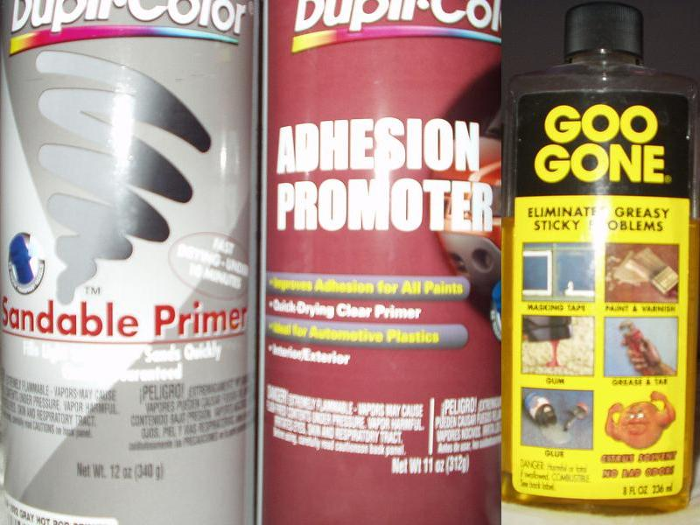
Sandpaper and scuffer pad:
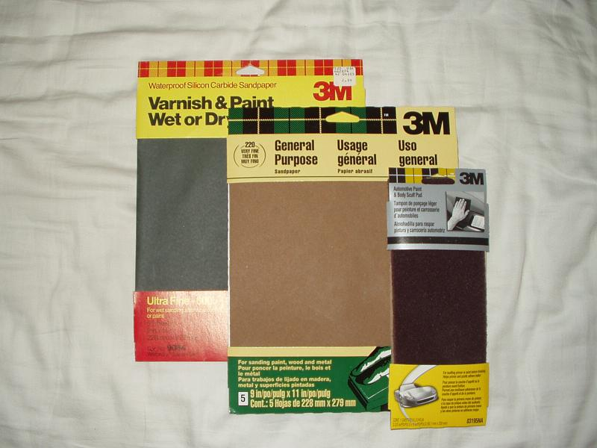
Polishing compound and car polish:
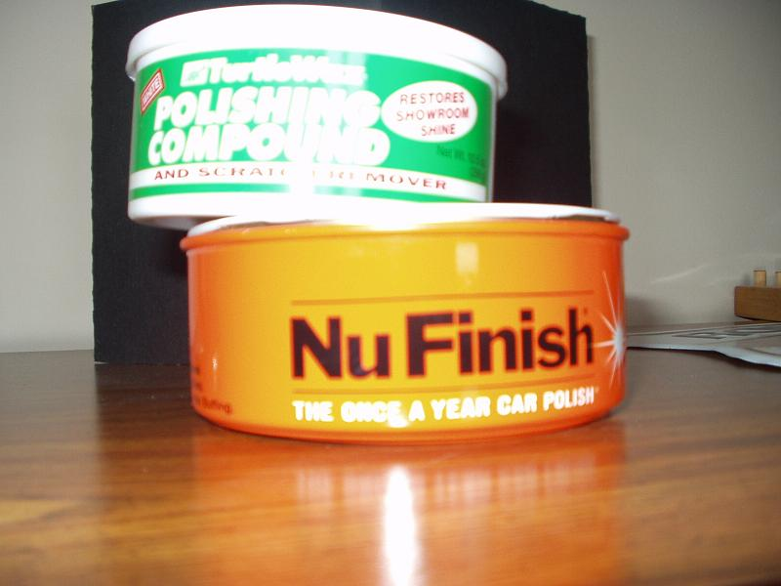
The grill I will be working on:
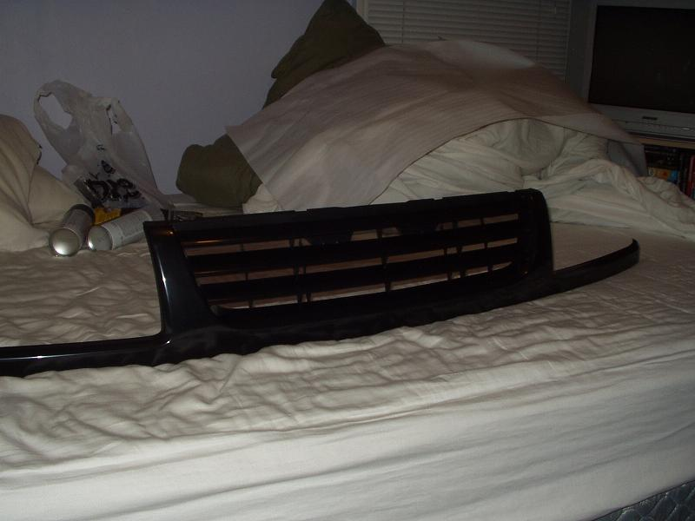
Things to keep in mind throughout the project:
-let the products dry up a bit between coats (except adhesion promoter)
-let the primer dry according to the manufacturers recommendation before sanding it, and add time if its cold where you are doing it.
-pretty sure you are supposed to do your clear coat within 24 hours of your base coat for them to completely and chemically adhere to one another
-do not use any kind of wax on the grill for at least a couple months as it will create a barrier and not allow the solvents to evaporate fully
1.) Sand grill with 220-320 grit paper until the smooth/waxy/shiny finish is gone on the entire surface you want to paint. Use the scuffer pad to get the hard to reach 'nooks and crannies.' Remember, any part of the plastic that does not get sanded, will be easy for the paint to peel right off (especially if you car gets to experience the winter and/or other extreme weather conditions).
The grill after sanding (u can tell which part is sanded and which I have yet to do):
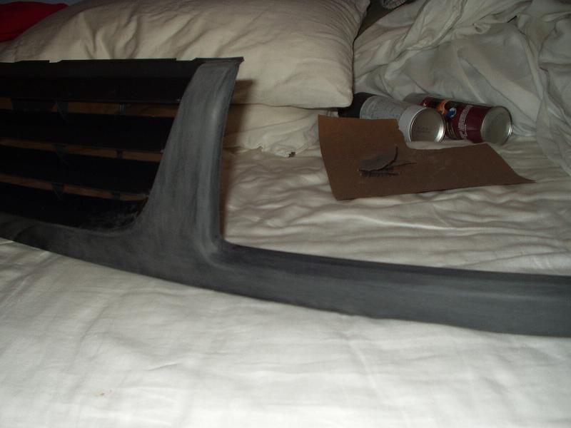
2.) Wash grill thoroughly with wax and grease remover. All I saw at autozone was a huge bottle of this so I decided not to buy it and instead I am washing with goo gone...and then afterwards, proceeding to wash with soap and water. The main thing here is to have a clean surface for your primer coat to adhere to. And remember, fingerprints are bad! (I used some white cotton gloves to handle the grill after it was cleaned).
3.) Important: Don't start this step until you are ready to put on the primer coat right after (as this is needed while the adhesion promoter is still wet).
Spray a coat of adhesion promoter on the surface area of the grill that will be painted. The adhesion promoter will help to make sure the 'nooks and crannies' that were tough to get sanded well, will grab ahold of the primer and hopefully hold on! Now, while the adhesion promoter is still wet, do your first coat of primer. Let that coat dry and do another coat of primer (2 coats of primer should be enough if you thoroughly convered the plastic).
Let the primer dry according to the manufactureres recommendation, and then proceed to the next step.
4.) Wetsand the grill with the 600 grit paper (if necessary). I actually found that my primer coat was smooth enough to not do any sanding before the base. Although, if sanding, this time the scuffing will be much smoother because of the finer paper and the wetsanding.
Primed and ready for color:
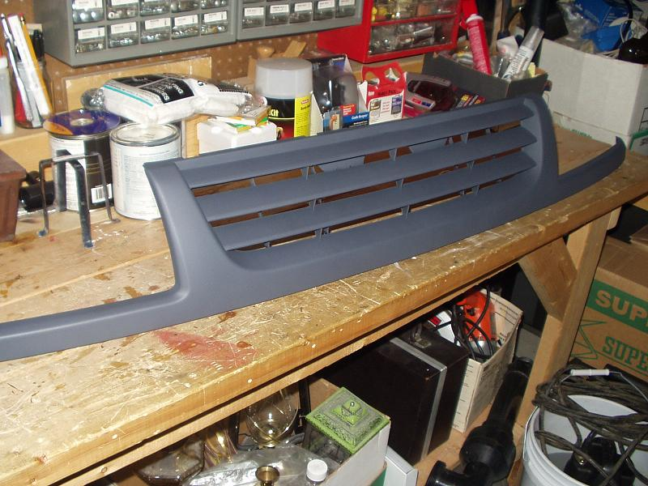
5.) Paint with your base coat (color)...(2 coats at least...more if your coats are very thin)...cant go wrong with too little per coat, but definitely can go wrong with to much!...Let dry
6.) Paint with your clear coat...a couple coats, as you will need to wetsand a bit to bring out the glossy finish. Let dry completely...I'm not sure how long this takes, I waited 24 hours.
Grill after base coat and clear coat:
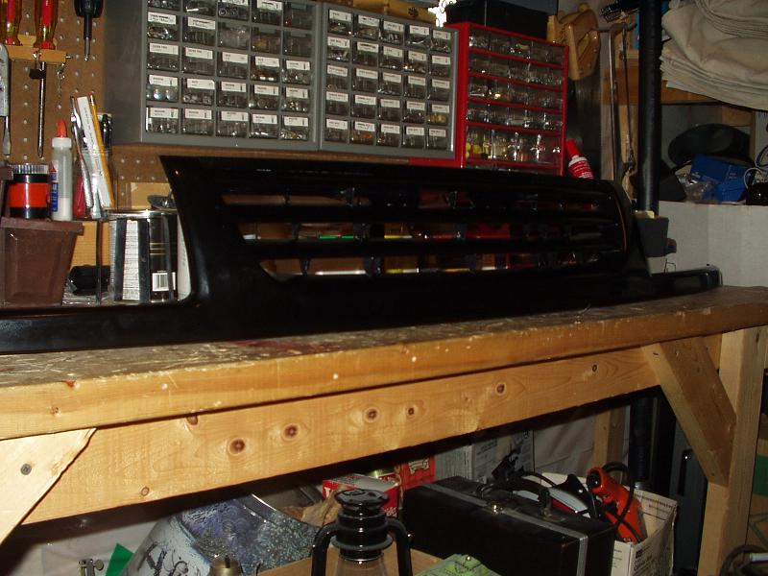
7.) My grill came out with sort of a dullish glossy look, so when it was completely dry, I wetsanded the front area (not the horizontal bars) of the grill with 2000 grit sandpaper. Then used polishing compound on the entire grill. I would suggest some power polisher but I didn't have one so I polished for about an hour by hand. After the compound (to remove the texture), I used a car polish that did not contain wax, and shined it up. The front part of the grill, that I wetsanded, came out looking exactly like the finish of the factory paint job
Pic of the finished grill after polishing compound and car polish:
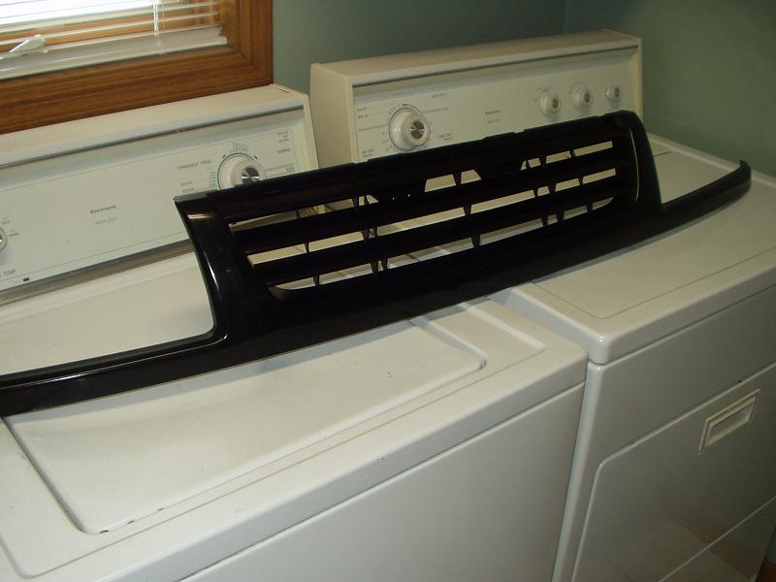
One issue I ran into during this project was a common issue I believe...A clip snapped off my grill, and it turned out to be an important one. The clip that held the main grill part to a smaller grill frame on the back was broken on one corner, so when it was on the car, it twisted it in some way and the corner stuck out. So I got same plastic bonding glue. and glued the hell out of it. And let it dry for 24 hours.
Then after it was dry I put a tiny (but wiide) plastic screw through the clip to make sure the glue wouldn't fail.
Heres a pic:
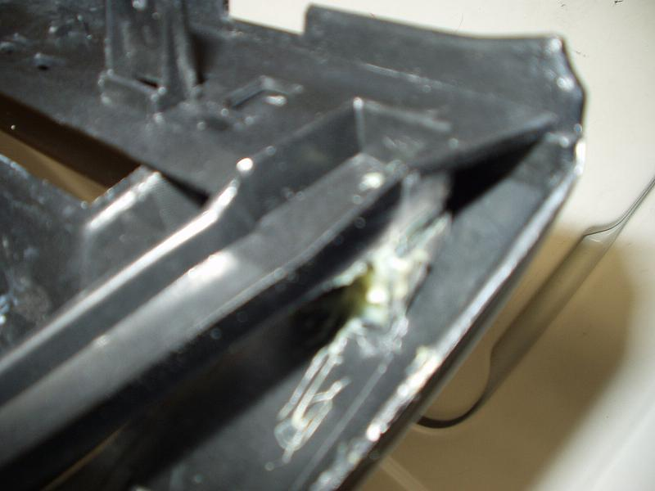
The glue and screw held strong and the grill fit perfectly.
Completomento
Here's a couple pics of it on my car:
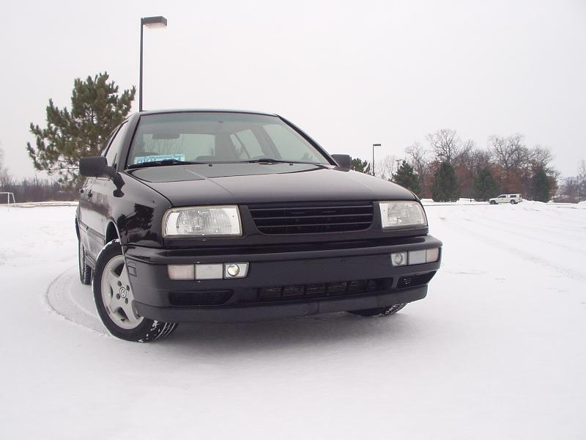
A lil later:
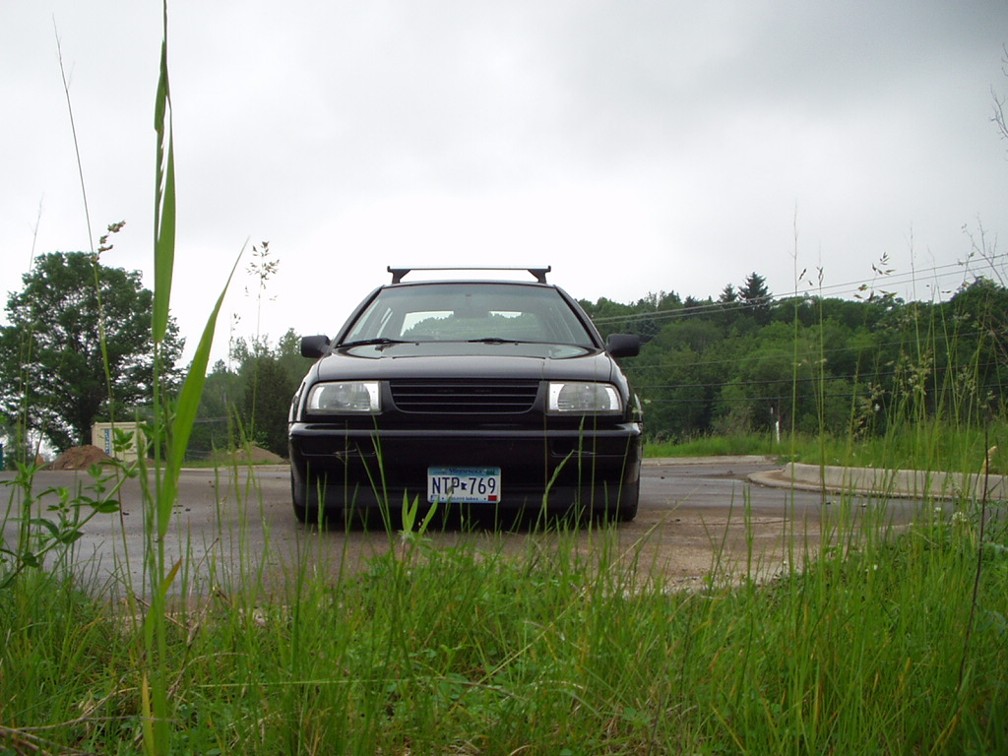
and thanks golfstormvr6 and moe sizlack for the tips, was a huge help

