Well since no one has submitted an aftermarket alarm to MK 4 switchblade remote circuit board swap, I thought I’d post one after completing the final steps last night. This DIY is for a Black Widow 2 button remote. I am sure that all these generic 2 button remotes are very similar and the procedure would be very similar. Most fobs are approximately the same size so I am assuming that if you are going to attempt this, you will have something similar to the size of my fob in the pictures to follow.
The tools that you will need to work with are
- razor knife
- soldering pen (15-25 watts)
- some sort of small vise to hold the piece your working on(I used my fly fishing, fly tying vise)
- wire (I used cat 5 ethernet cable. Small gauge solid copper wire that is color coded)
- small chisel
- multimeter
- electrician’s tape
- extra LED’s. Surface mount LED’s are small enough to fit in the space required. On the original Mk 4 keyfob there is a surface mount red LED that will fit nicely (assuming you have the same keyfob that I got off of eBay). I broke the contacts on my original one so I ordered 5 red and 5 green from my local electronics store.
Here is what I had to work with.
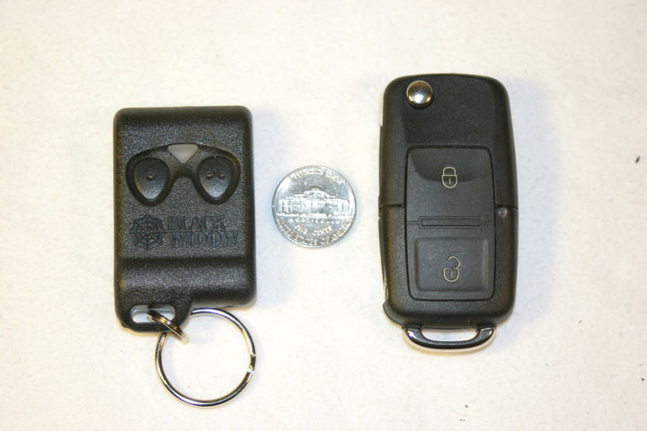
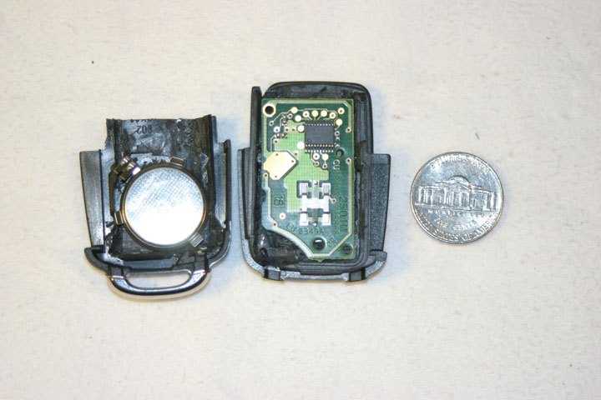
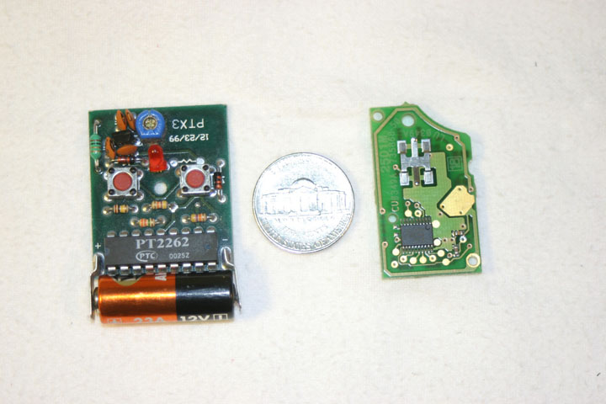
First things first. If you are going to attempt this, make sure you have the aftermarket alarm keyfob programmed. On my first attempt, I used an extra fob I had lying around and didn’t remember to program it. From the first cut I didn’t know if it still worked or not. On the second fob I realized that programming it prior to cutting the circuit board was a must. I essentially used my first fob as a mock up making sure the cut pieces fit the interior of the fob space wise. The second attempt had me running back and forth from my work desk and the car making sure that the fob worked with every new cut and solder. I highly recommend that you take it very slow and make sure your remote works after every cut and solder. Otherwise you are flying blind. Also I stuffed a sock in the aftermarket alarm’s siren so that you could hardly hear the chirp chirp when arming and disarming the alarm constantly throughout this process.
The biggest challenge was getting that big battery into the small space. I had to work around the things that I could not change. I tried to use the 3 volt button battery but the alarm fob decided not to work after hooking it up to the terminals. At first I thought that I would never be able to fit all of the guts of the aftermarket keyfob into the Mk 4 fob but after gutting the interior of the fob of any extra tid bits. I had more room to work with. I took my soldering iron and melted away space for the battery and circuit board then took a chisel and razor knife to cut any of the melted plastic that was still in the way.
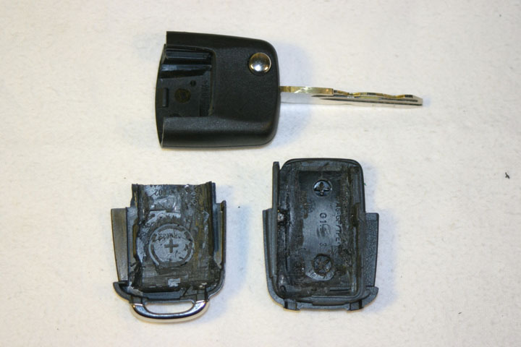
You will constantly have to make more room for the components so don’t do any extra work that you don’t need to. Just cut away the obvious things that are sticking out like the circuit board plastic pins and the battery housing for now.
On to the circuit board. Here is a picture of the prospective cuts I will need to do.
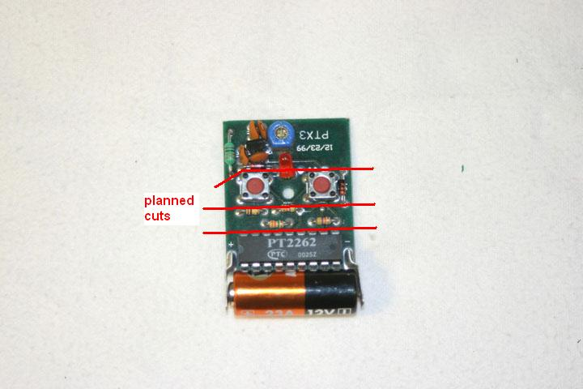
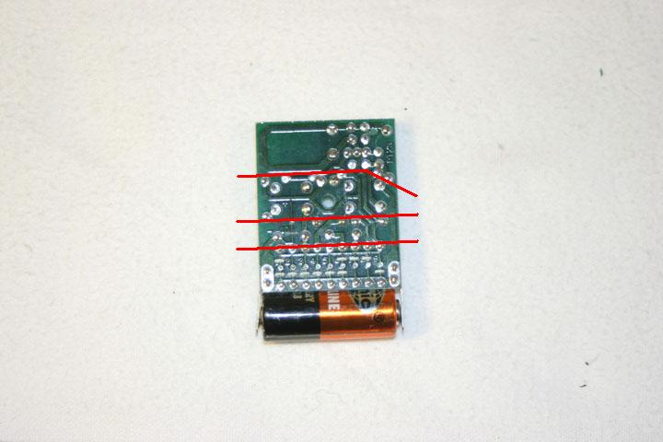
After making the first cut on the bottom, I soldered solid wire to the chip fingers that lead down to the circuit to save space. To attach the leads that led from the back and front of the circuit board, I scraped the green circuit board coating coving the copper traces and then prepared the surface and wire you are adding with a touch of flux. The key here is to get some solder onto the tip of your pen first so that you are not waiting for the surfaces to heat up when you have your pen touching the components. Damage can occur if too much heat is applied to the delicate components. Essentially I just tapped the parts I wanted to be attached with the soldering pen and let them fuse together.
Here is a picture of the original cut circuit board. Please note that with the second attempt, the first cut was made and then attached to the remaining three quaters of the circuit board and not as shown as the second cut half way up the board.
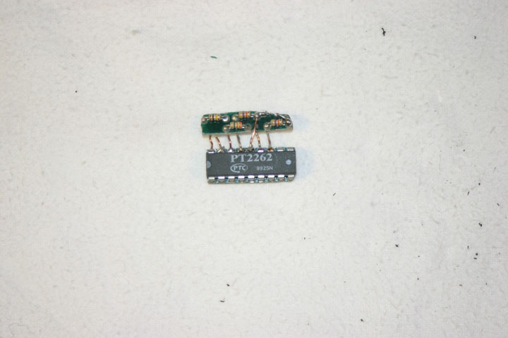
With the first cut, I left everything in tact including the battery terminals so that it was easy to test the unit. I clipped the terminals off at the last moment for final fitament. Now for the test.
A point of note, when you have the bare circuit board and are attempting to test the fob, make sure you are not touching the circuit board with your bare hands. I found that a lot of the initial tests worked sometimes and sometimes not depending on how I was holding the bare fob. I am assuming the circuits were either grounding or shorting out on my oily hands or something to that effect. I just held the keyfob in my shirt while testing and that seemed to work fine.
I pushed button 1 and it armed/disarmed, then on to button number 2 and the same. Test completed. Now if you find that you are not getting the results you would if the original circuit board was in tact then back track to all the circuits and make sure you got them all. On the initial cut I had to make 8 connections (16 solders). Make sure the fob is working properly before you move on to the next step. It’s impossible to trouble shoot these little things unless you have some sophisticated equipment which I am sure most of us don’t have. After cutting the first fob, I was left wondering what the hell? I had to move onto the second fob because I didn’t know where to begin. I cannot stress enough about testing the fob at every step. Don’t skip it cause you will regret it and give up on the project (Positive reinforcement!!! Sort of like dogs and treats; humans and chirp chirps).
After making the second cut, I used longer wires to attach the bottom half to the top half. I would eventually replace the third quarter of the circuit board with buttons and remove the third quarter all together. Attach all the leads of the first half of the circuit board to the leads of the second half.
Test your fob. Make sure your fob is working properly before moving on.
At this point, on the third quarter of the circuit board, there were only three components; 2 buttons and a diode.
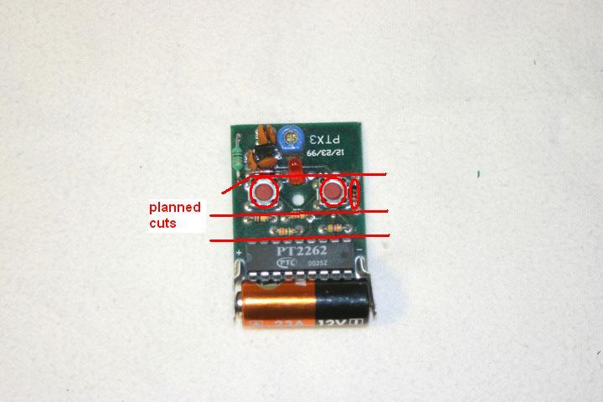
I started to trace the leads that were from the third quarter up to the fourth quarter and moved any wires that I could and attached them to the fourth quarter trying to bypass the third quarter all together.
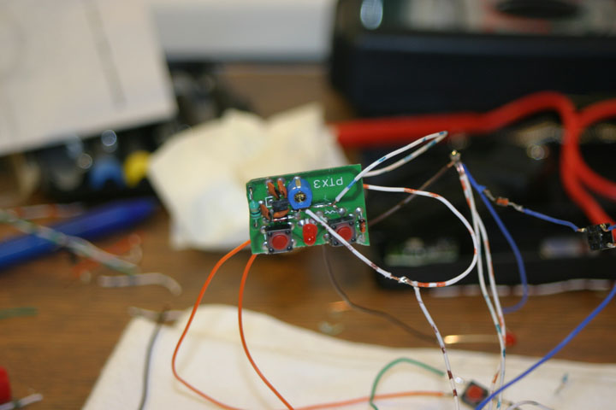
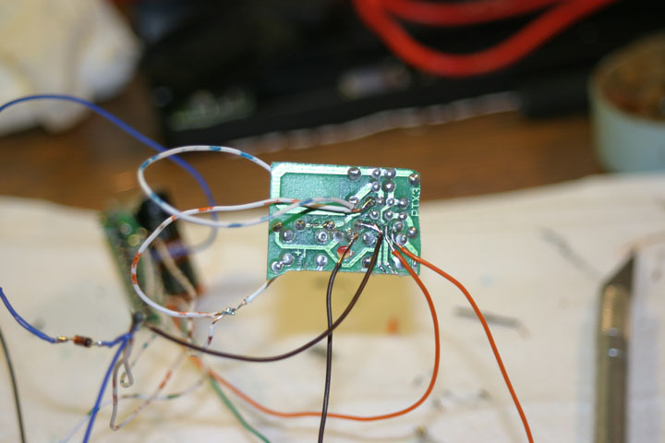
Test your fob. Make sure your fob is working properly before moving on.
I now took any wires that were attached to the buttons and added 2 more buttons and transferring any wiring from the buttons on the circuit board on to the 2 buttons that I had externally. I then removed the diode from the circuit board and attached it in the right place according to the circuit.
Test your fob. Make sure your fob is working properly before moving on.
At this point after removing the third quarter completely and now have a working keyfob albeit a wiring mess, but none the less a working key fob, you can now start to try and make everything fit into the space requirements. At this point you want to eliminate the battery terminals and cut away as much material as possible away from the chip. Attach wires to the leads that were once the + and - of the battery terminals. I soldered the + and - to a battery so that I could continue to test. Pay close attention to the leads coming out of the chip. On my first chopped fob I missed a ground coming out of the bottom corner.
Test your fob. Make sure your fob is working properly before moving on.
Here is a comparison of the original aftermarket chip to now
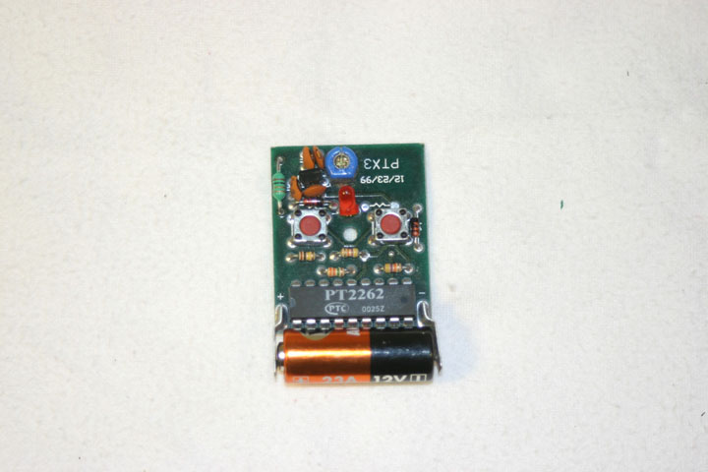
As you can see, I cut away a crap load of material and even cut into the soldering joints of the chip fingers into the circuit boards in order to gain more space. One of the more challenging things was to get that chip to sit well back into the remote. I will post the finished circuit now so that I can refer to it.
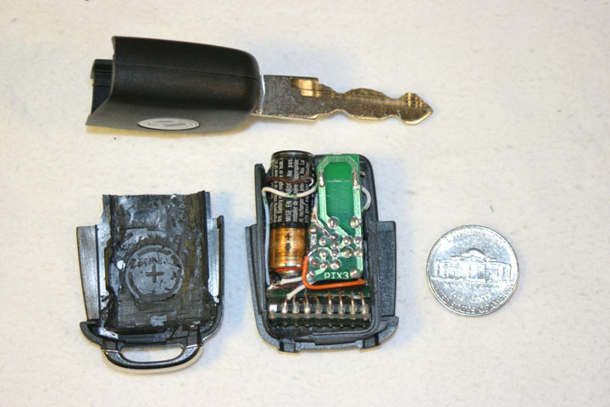
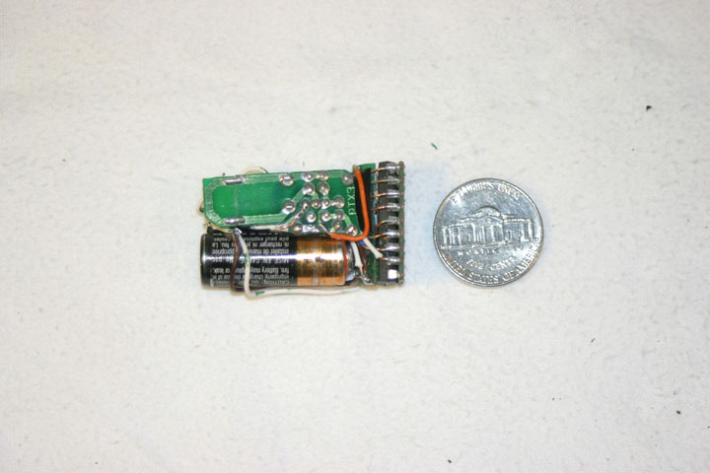
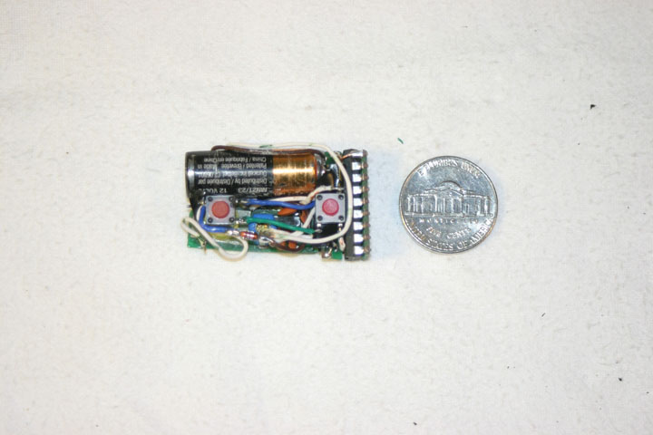
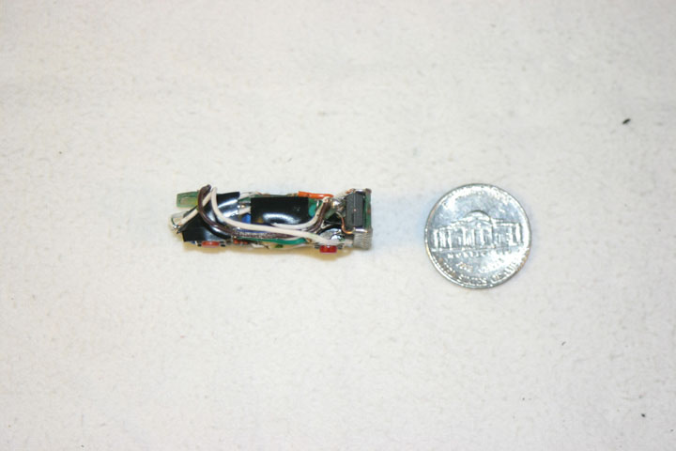
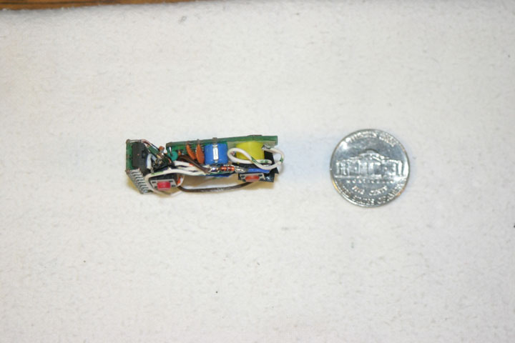
If you compare a new Mk 4 fob to mine, you will see that I have cut part of the top off on one of the pieces and taken a few walls out to fit everything in. The original was water tight but there was no way in hell that I was gonna fit everything in with those walls there.
Ok now you have to shrink your wiring mess to a small unit as above. The key fob at this point should still work.
The next step I took after making sure the chip was fitting into the fob was to work on the button positioning. I started with the button closest to the chip. Cut the wire to the right lengths and then soldered them together. Did a dry fit and made sure that it clicked.
Test your fob. Make sure your fob is working properly before moving on.
Next step is to get the positioning of the second button. I cut the wires and soldered them together.
Test your fob. Make sure your fob is working properly before moving on.
Next step is to shorten all the wires that lead up to the forth quarter of the circuit board. This one was the most nerve racking because in order for you to get that part of the board close, you have to disconnect all of the wires that you just attached. Make sure you copy down what wire leads where. Take pictures like me if you have a camera just for reference.
Test your fob. Make sure your fob is working properly before moving on.
The most frustrating part for me at this point was disconnecting all of the wiring then reconnecting everything into the compact unit and not have it work. I couldn’t figure out what was wrong. I checked and rechecked everything over and over. I decided for some odd reason that I should check the battery and what should normally read around 12 volts was reading around 1.2 volts. Changed the battery and voila, the fob worked again.
While you are fitting the components into the fob and have a working fob, I suggest disconnecting the battery so that you don’t accidentally set the alarm off at any point and annoy your neighbors.
After trying and fitting in all the components, you may find that you don’t have enough room for everything. Time to take out your trusty razor knife, soldering iron and chisel. Chip or melt away at the parts of the Mk 4 fob that are getting in the way.
Just as a side note, I cosmetically did not alter the exterior of the fob at all except of the key itself and changing the red LED to a green one to match my interior.
Keep fiddling with it until you get the fit you want and the buttons are performing correctly. I found that with the bottom or first button, I didn’t have to support it as far as pushing it towards the button on the outside of the fob. There was enough pressure on it to keep it in place. Only time will tell if it will shift or not but so far so good. As far as the second button is concerned I had to wedge a piece of plastic in there (the yellow piece of plastic in the side view of the circuit above) to keep it down and snug up against the fob button.
I reconnected the battery at this point to test it to make sure it was still working properly. I found that when I put the top and bottom of the fob together and compressed the innards, odd things would happen like two bare wires touching or something making the fob not work. I took some electricians tape and insulated and exposed wiring that might cause a short. That helped tremendously because I would test it at one point and it would work fine and the next time, without changing any of the wiring at all, it wouldn’t work. The tape fixed all of that.
At this point it’s quite a fiddly process making sure everything fits. Uninstall cut some more, scrape, melt, cut away, then reinstall. Very finicky stuff but worth it if you want the fob to work properly.
Well that about wraps it up. Hope this helps someone who is attempting this and needs even a little bit of a hint from what I have gone through. If you have any specific questions, feel free to im me or post up here.
Doug

