http://www.ohiovw.com/tools/regulator/default.asp

Required Tools
10mm Socket
Flat head Screw Driver
Large Philips Head Screw Driver
T10 and T25 Torx Bits
Electrical Tape
Window Regulator
- Drivers Side Rear - 1h4839461a
- Passenger Side Rear - 1h4839462a

Before we get started please make sure you have all of the tools listed above, and roughly 1/2 to 1 hour to complete this process.
Step 1
Unpack your new regulator
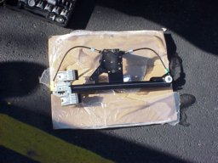
Step 2
Use the flat head screwdriver to pry off the switch, be careful not to break the clips off the back side, or marr the plastic.
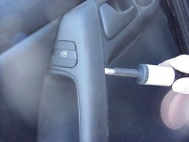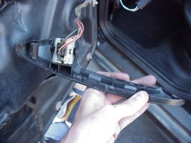
Unclip the switch from the door.
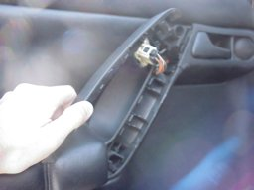
Step 3
Pry off the speaker, make sure you do not break the clips off the back of this piece either, or else it won't be held in strong enough when you put it all back together.
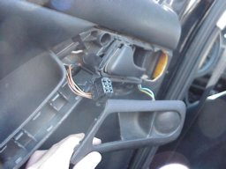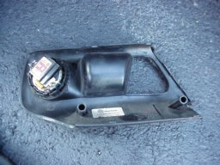
Step 4
I did not snag a pic of this step, but behind the handle there are two large screws, use the large philips screwdriver to remove these two screws.
Step 5
This is what holds the panel on, pins and pin holes, knowing this gently pry between the door panel and the door. I say gently because these "pins and holes" are quite fragile and have a tendancy to break, or pull the pin from the door.
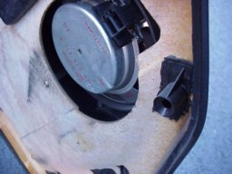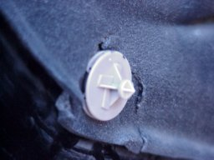
If you pull a pin from the door, don't worry it will go back in, but if you break a pin hole, its all over for that pin hole, so be careful (You shouldn't have any problems)
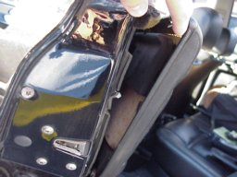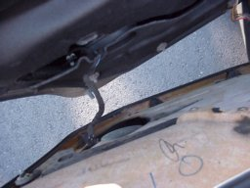
Here is the back side of the door panel.
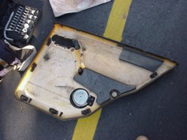
This is what a pulled panel pin looks like
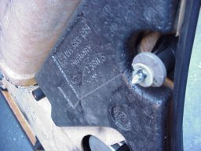
Step 6
Looking at the inside of the door, you will see a large sheet of dynomat (Dynamat) its for sound deadening, so you don't get rattles and whatnot from the music, or just general rattles, this needs to be gently pulled away.
Its no big deal if you rip this material (You can see in the picture mine is ripped) noone will ever see it.
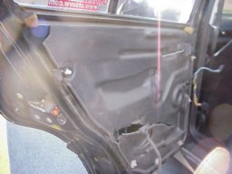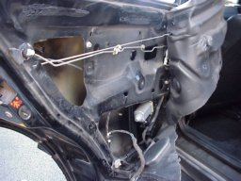
Step7
Once you have pulled away the sheet of dynomat you'll see the busted regulator (That damn fool!) Use the 10mm socket to unbolt the regulator from the glass and jiggle the glass. It may take a little force, but you need to seporate the glass from the regulator.
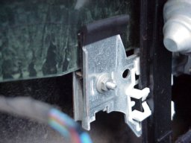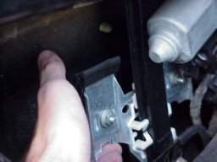
Step 8
Now, use the electrical tape to hold the glass up near the top. (You don't want it down in your way, while you are removing the regulator.)
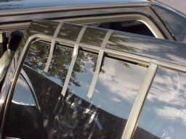
Step 9
Use the 10mm socket again to unbolt the regulator (There are 3 bolts total holding it on)
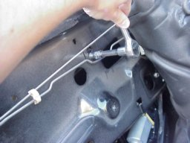
Step 10
Jimmy the regulator to a position to where you can get at the electrical plug, unplug this.
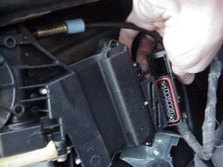
Step 11
Tilt and giggle and complain a little, but pull out the regulator from the door.
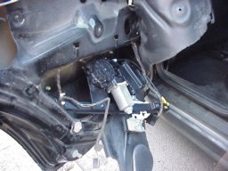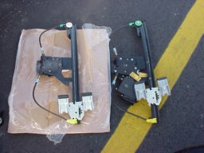
Step 12
Now for the heart transplant!
Use the larger torx bit to unscrew the large torx screws, and the smaller torx bit to unscrew the smaller screws.
NOTE! you do not need to remove all of the small torx screws, just the ones holding the motor to the regulator (Compare regulators and only remove the screws that you will need on the new regulator)
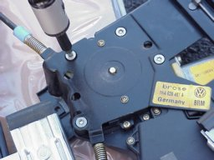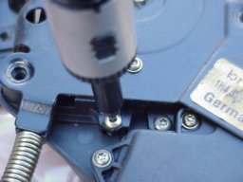
Step 13
Now that we have our motor off of the one regulator, we need to re-install it on our new regulator, simple just screw it back on!
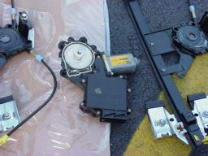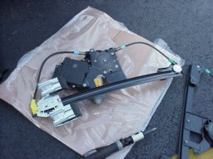
Step 14
Re-install regulator back into the door, re-attach the electrical plug and bolt it down with the 3 bolts (Make sure you remove the bots before you try to jimmy the regulator back into the door or you will shout "DAMNIT" as you jimmy the new regulator back out of the door to remove them.)
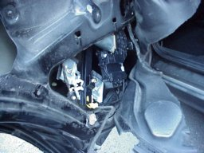
Step 15
Now that your regulator is back in the door, un-tape the glass from the door and gently slide it back into the regulator "fingers." Use the 10mm socket to tighten up the regulator to the glass (Not too tight as to break the glass, but tight enough to hold the glass)
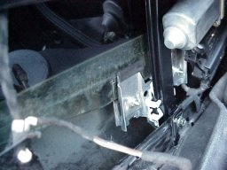
Plug in the switch and roll up and down the window to make sure you have the glas in streight, so the motor doesn't have to labor to roll up or roll down the window.
Step 16
Re-install the dynomat (Use the old goo, it is pretty damn sticky stuff.)
Plug in the speaker!
Then the lign up the door panel (I found that if you put the door panel on and pound with a closed fist where the pins are, they stick pretty well.
Screw the two screws back on that go behind the handle.
Plug in the tweeter speaker, and clip that bad boy back on
Plug in the switch and clip that back on.
Pretty painless.
All information believed to be accurate but is not guaranteed.
Volkswagen is a registered trademark of Volkswagen AG.
OhioVW is not affiliated with or endorsed by Volkswagen AG or Volkswagen of America, Inc.
Top of Form
Bottom of Form

