Do It Yourself: Changing Fuel Filter in MKIII Golf/Jetta By JetTAFLiTe & kevinvr6 (vwvortex)
This DIY has been sponsored by GTR Direct. For all your computing needs!
http://home.earthlink.net/~kevinog/diy/diyfuelfilter.html

Parts needed:
-Fuel Filter - Part No. 1H0-201-511-A (Approx $23 from VW dealer)
-2 Adjustable hose clamps (not sure on size, but the screw needs an 8mm socket to turn, or flathead screwdriver)
-Something to catch the dripping fuel
Tools needed:
-Car jack
-Jackstand(s)
-17mm socket
-Flathead screwdriver
-Snippers
Safety Precautions:
-Don't leave lightbulb in work area
-Have fire extinguisher closeby
-Becareful

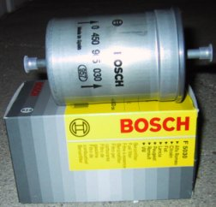 | 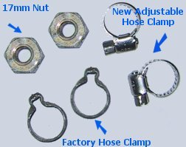

1) Before you begin, you must remove relay #12 position #167
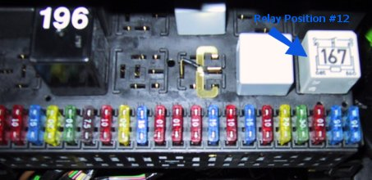
2) After pulling the relay, Start the car and crank the ignition a few times to depressurize the fuel lines. (the car will try to start but it won't, don't worry)
3) Disconnect the negative battery cable.
4) Jack the car up and secure it with jack stands, then remove the wheel. It's right under the right rear quarter panel.
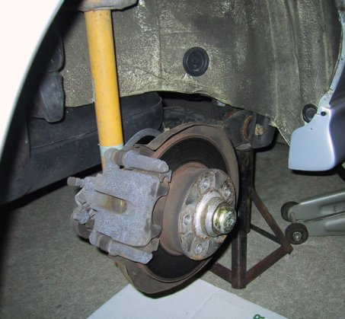
5) Locate the fuel filter and familiarize yourself with the parts involved.
Side View
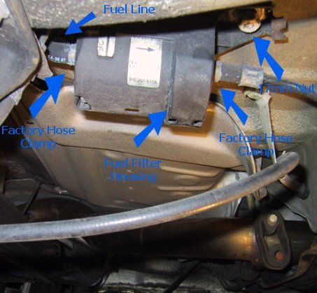
Under car looking up
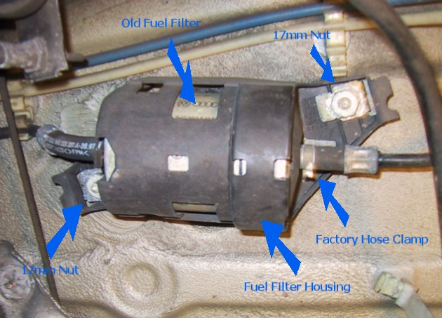
6) Break/Snip/Cut away the factory hose clamps, you will not be able to re-use them.
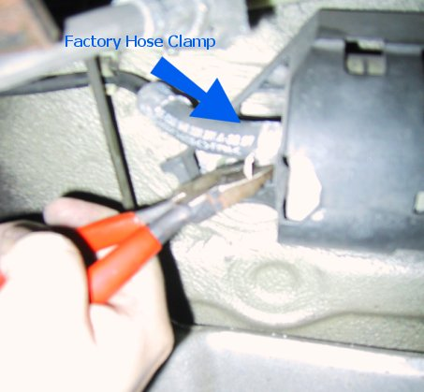
7) Pull the fuel lines away from the fuel filter (it will drip so have something ready to catch it, or just let it drip all over the driveway to make a big puddle :) )
8) Remove the 2 17mm nuts and drop the fuel filter along with the housing. It will require some strong pulling to remove the housing.
9) Remove old fuel filter and install the new one, make sure the arrows on the new fuel filter point towards the engine.
10) Re-install fuel filter housing with the new fuel filter inplace, Screw on the 2 17mm nuts, and secure the fuel lines with the 2 adjustable hose clamps.
11) Put the wheel back on, remove jack stands, lower the car, put the relay back in, connect negative cable on the battery and start the car!

If you have a performance chip installed (ie. Garrett, TechTonics, Neuspeed, Autotech, Autothority) you will need to reset the ecu.
Disconnect the negative battery cable for 10mins, then reconnect the battery, plug the key into ignition and turn to the "ON" position (do not start the car).
Leave the key in the "ON" position for 7-10mins, afterwards, start the car and let it idle for 7-10 mins and you are done!
Disclaimer: Try this at your own risk, we are not responsible for any injuries/deaths or damages to your car. Be safe!

