For all of you who have smoked lighting (turn signals and GLX tails specifically), you know that if you really take a close look at the turn signals or your GLX tails, you'll see an orange glow to them.... which doesn't look good. So here is a DIY to get rid of that orange glow.
This isn't a new subject, but I thought it would be good to put it alltogether in one thread. So here we go:
Can't really tell here, but you can in person, and that's where it counts.
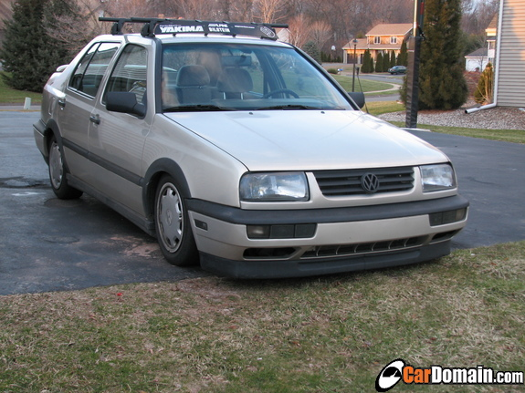
GLX tails before: notice the amber glow on the passenger side

What I started with:
) European specification turn signals with no amber lense, orange bulbs, and retro-fitted to use the U.S. specification 3 prong plug.
) GLX tail lights with normal white bulbs and connections.
What you will need:
) 4 stealth bulbs (1 pair 1157, 1 pair 1156, that appear silver but light up orange)
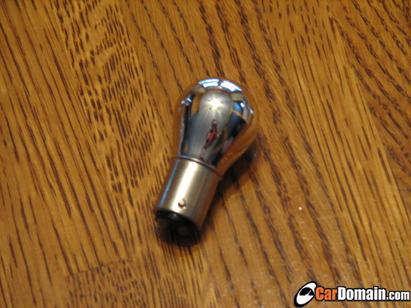
I got these on ebay for $6.49 a pair shipped.
From this ebay member: "galagolo"
) Dremel tool
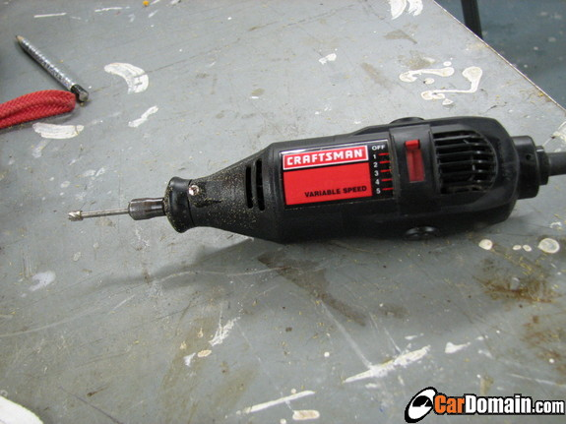
) Regular screwdriver
) Needle-nose plyers
) Hammer
) Vacuum
) (optional) narrow, hollow tube)
) Safety Goggles
Smoked Turn signals:
This part takes 5 minutes. Take the screw driver, pop out the dummy panel and remove the turn signal. Disconnect the plug, push down on the plug and twist to the left and take it out. Swap out the regular bulb for the stealth bulb....... and you're done. Put that back together and be careful not to break any of the tabs while putting the dummy panel back in.
Comparison shot. Ambered on the left, finished product on the right
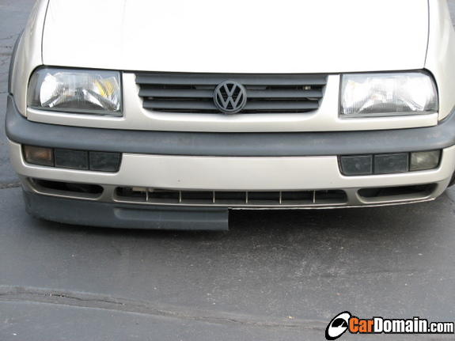
(being lower does have its disadvantages )
Finished:
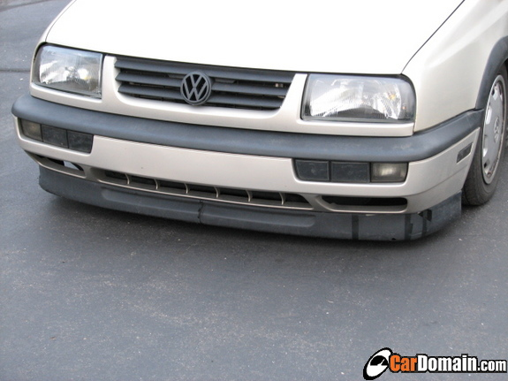
(Lip mended too )
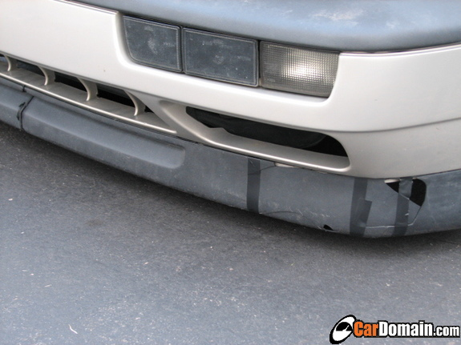
Hella Jetta GLX tails:
This part takes a little longer.
Open your trunk, turn to the left or right and peel back the carpet in the corner behind the outer tail lamps (the carpet that is against the backside is behind the carpet against the sides of the car). Remove the lighting harness carefully, so you don't break the bulbs. Take the 8mm deep socket and remove the 3 nuts that hold the tail lamp in place. Take out the outer tail lamp.
Now, if you look inside the turn signal housing, you'll see a little orange cup that surrounds the bulb, which not only dims the light, but makes it cast an orange light (and the orange glow when they're not on). Take the screw driver, put in in the hole of the the housing against the amber cup and LIGHTLY tap the screwdriver with a hammer to pop it out of position. I cannot stress enough how important it is to be very gentle with that step; you do not need a lot of force to separate the glue (or whatever), and if you apply too much, you can break the tail light!.
It should be just floating about freely in there now. So you should be really motivated to get this done! .
So here's where it gets "fun". Grab the amber cup withe the needle-nose plyers and have at it with the dremel!
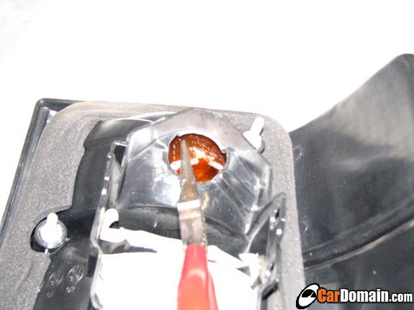
I recommend to take off small chunks at a time and just pull them out with the needle-nose plyers.
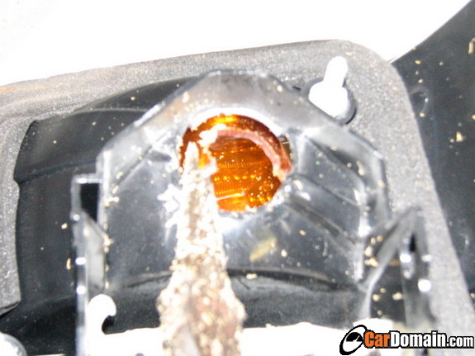
So, work your way around the cup, taking off small chunks at a time. then when you've taken off about half the cups height, go around again, doing the exact same thing.
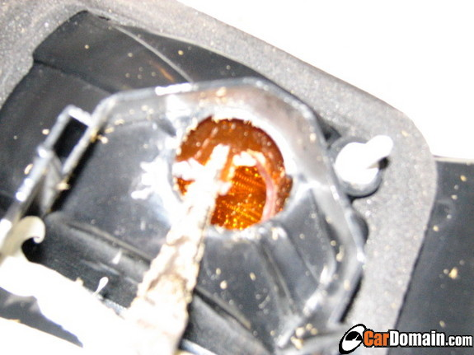
Soon, you'll be left with a little amber disk.
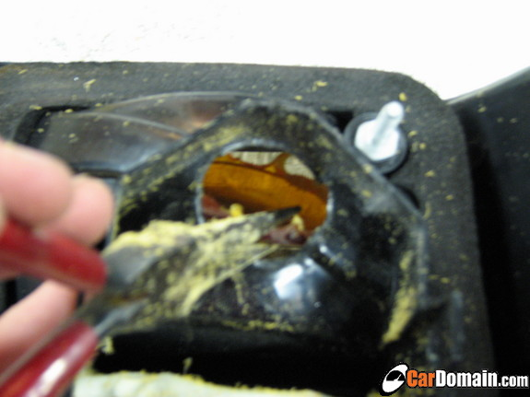
So, take the dremel and cut it in half. You can only cut so much at once, so attack it from the top and from the bottom.
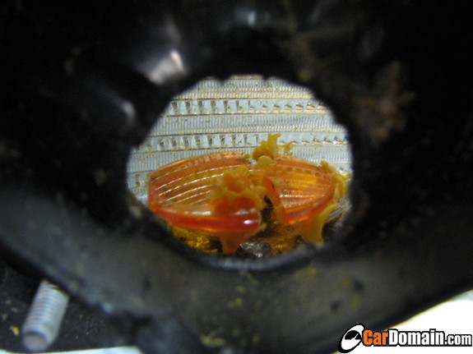
Now you should end up with something like this:
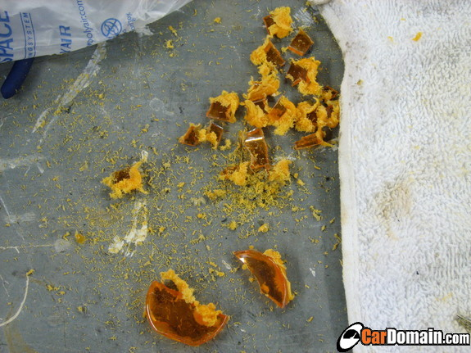
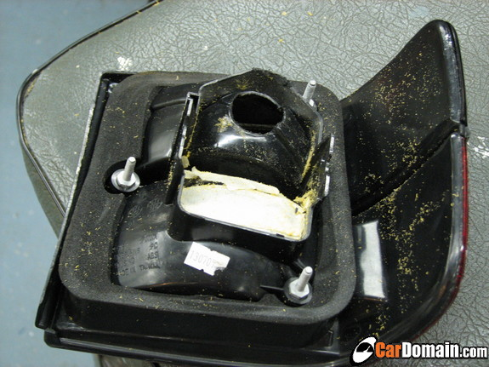
So Vacuum all the chips up. To get to the inside of the housing, what I did was attach a narrow piece of tubing to the end of my vacuum hose with duct tape and used that. You may have to tap the tail lamp against something hard, but not too hard, to get the chips out if they went around the corner.
So now that you've done one side, reinstall the tail lamp in the reverse order that you took it out, and do the other side.
Comparison shots:
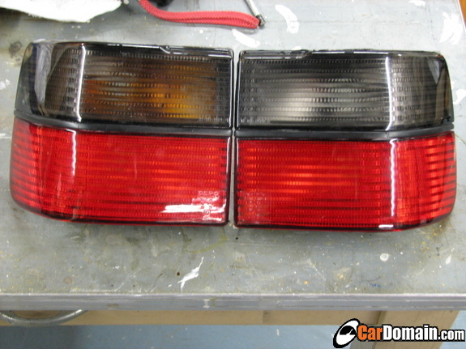
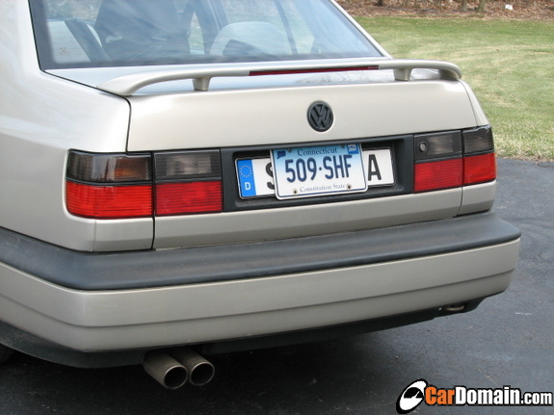
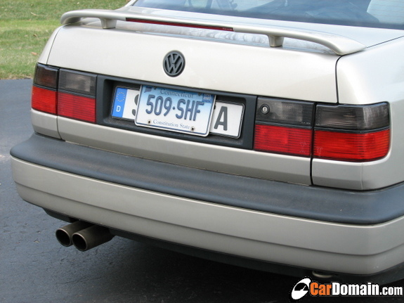
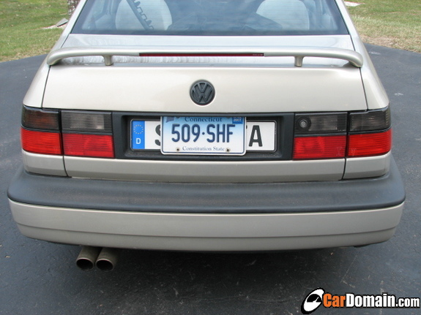
***Important***
DO NOT do this without putting some sort of amber bulb in the tail lights!!!
Feel free to ask questions
EDIT: Put all the pictures in Cardomain so they won't disappear

