DIY smoked fogs
You will need:
High temp black paint
Masking/painters tape
A type of silicone glue/sealant (black would work best to get the full smoked effect)
Razor blade
Rubbing alcohol
Screw driver(s)
If one or both of your lenses in cracked when removing it will come off in two pieces
1. Remove fogs from bumper…may be tricky. The first time I tried to get my fogs out I had to pull the bumper. Today I pulled my bumper because I was working on some other things. If you are pulling the bumper reach in where the turn signal is and detach the fog light harness before removing the bumper because the wires are very short.
2. Loosen adjuster screw. It is a hex screw however I used a small flat blade screwdriver, be careful not to strip it. Loosen until the projector piece is separate from the lens piece.
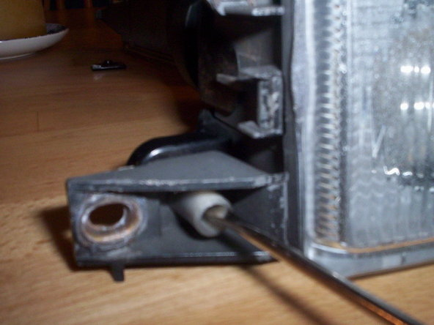
3. There are two clips on each side. Using a small screw drive lift then up very carefully because they will snap. Wiggle off until the 2 pieces are completely separated.
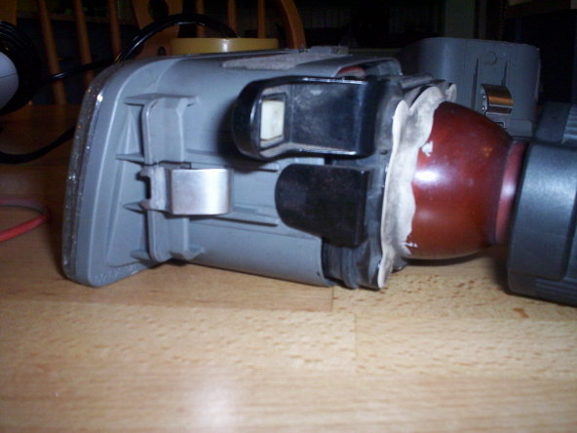
This is the clip, you can see how it locks in with a tab
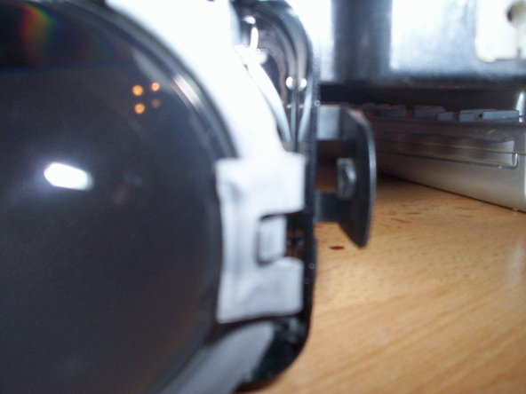
4. Use a razor to go around the edge of the glass and cut the existing glue
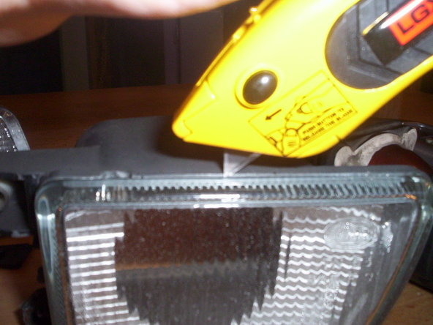
5. Use a screw driver and loosen the glass from the plastic, you may need to use the razor again. If it is being stubborn you may want to use a heat gun or hair dryer help loosed the glue. Be careful of the glass chipping.
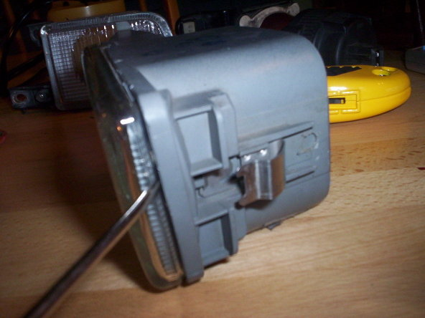
6. Remove glass. If your lens in cracked this is where it will split in two.
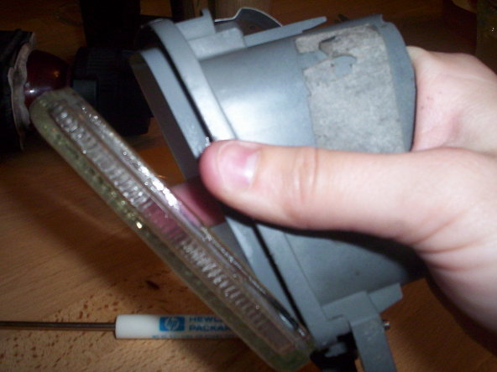
7. Use rubbing alcohol to clean where you will be painting. While you are at it you may as well clean the glass too.
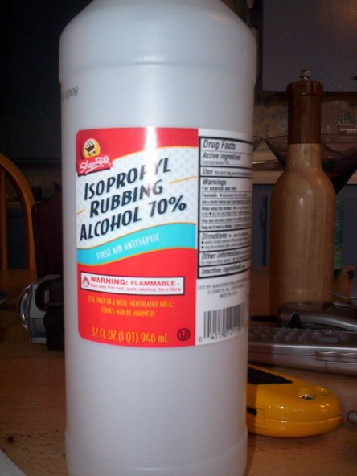
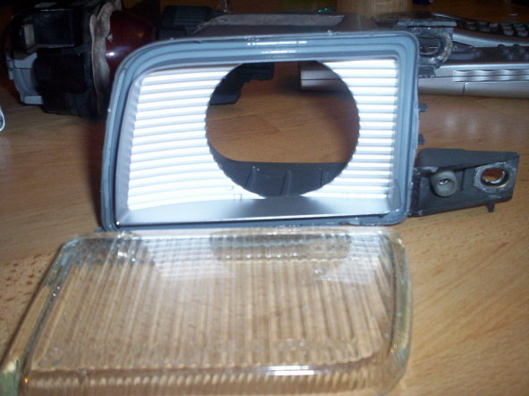
8. Tape off the plastic housing so no paint will go in the creases where you will be gluing the glass back in
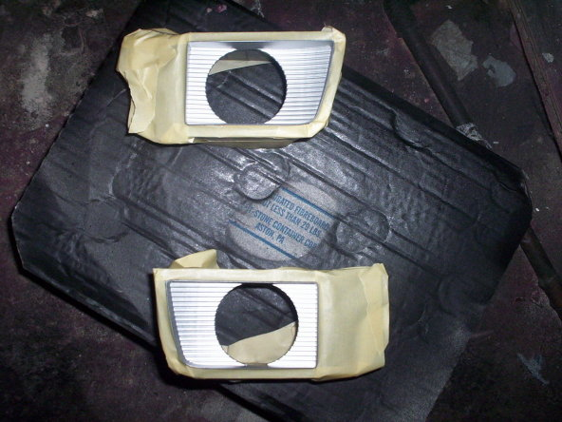
9. Using high temp black paint evenly spray both pieces. Start with a light coat then do a second coat, or however many you feel it needs.
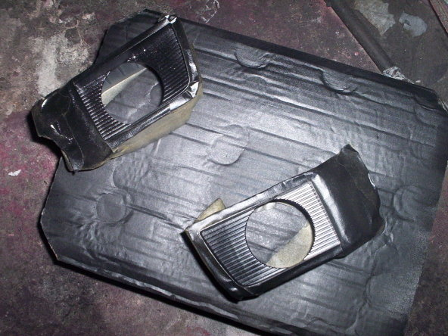
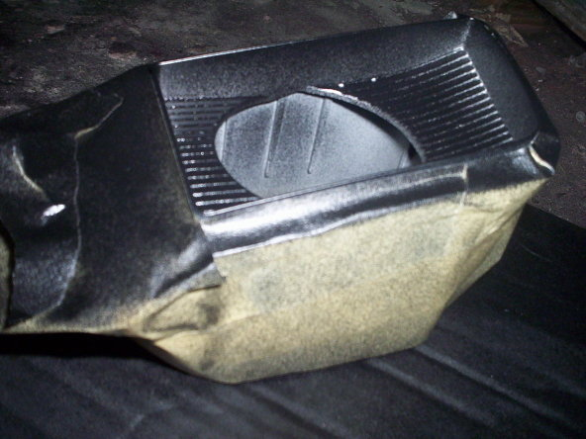
10. Remove tape and wipe lens and where the glue will be going with alcohol.
11. Using the silicone run a continuous bead all around the crease where the glass goes. (I did not remove the old glue because it had a shape to it the acted like a gasket.) If your lens is cracked put some glue in between the two pieces. (dont worry about it squeezing out, you can remove it when it dries.)
12. Put glass back on and squeeze firmly. Run your finger along the edge to remove any extra glue and to seal the glass in completely (be careful of glass chips). If you have some sort of clamp that you can use to hold the glass in place that would work fine. I did not use a clamp or vice and it worked out fine. If you are using silicone, don’t worry if some glue gets on the lens, once it dried you can rub it off.
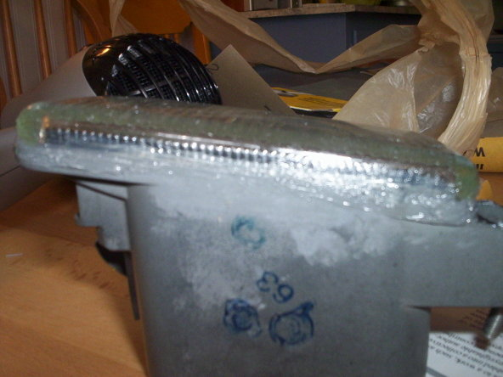
13. Allow time to dry and set
14. Admire your hard work
