I've always wanted fogs on a car of my own, but I didnt want to go the cheap Wal-Mart route. So I managed to suck up a couple bucks and do it the right way. Thanks to Parts4VWs.com, Martin, Wes, Juan and all the helpful vortexers out there that made this possible.
First off, You're gonna need the essentials.. The fogs themselves (duh), lenses, screws, a good understanding of what you need to do,
A headlight switch capable of the foglight ability
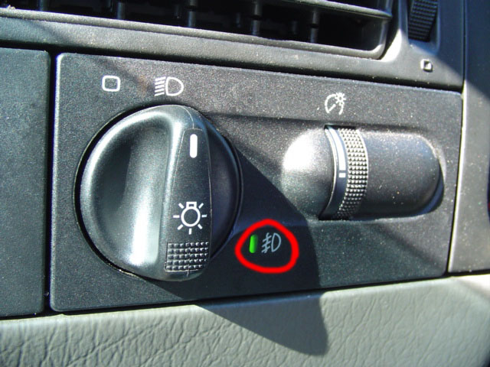
A 30amp automotive relay ($6.75 at Radio Shack)
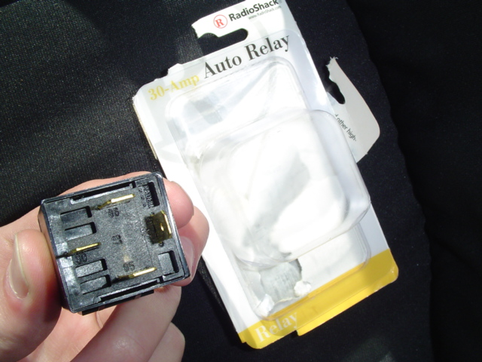
and..
The foglight wiring harness (that comes with instructions!)
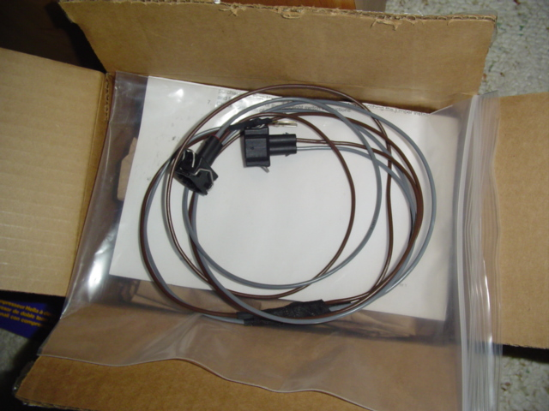
To prevent any hair pulling, take the 30amp automotive fuse and locate your fuse box, and remove the cover with the 2 screws on each side:
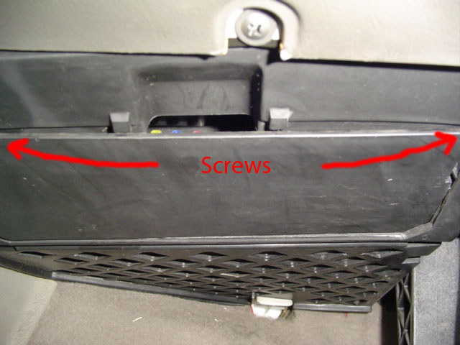
Now find the empty spot with a "10" marked on it. This is where that 30amp fuse goes, simply line up the prongs to the holes on the board and it should pop right in.
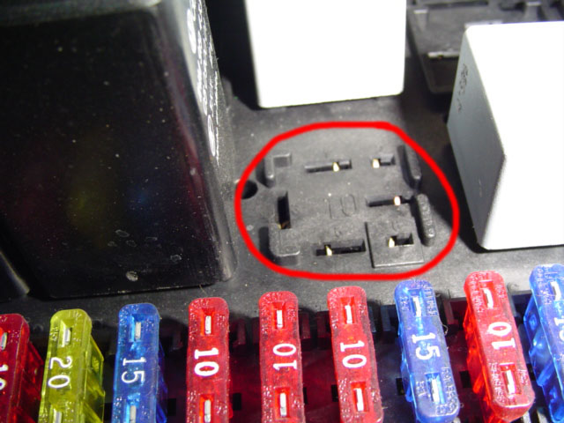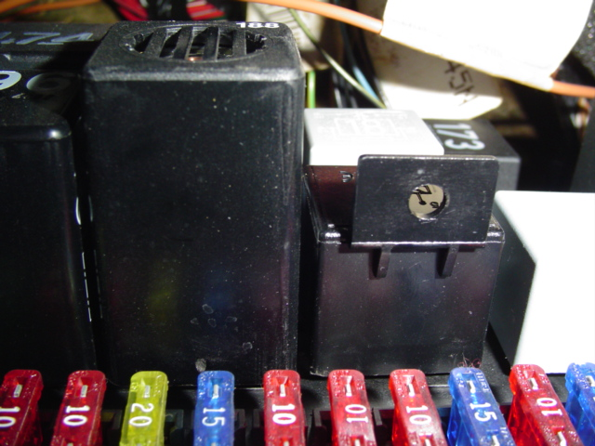
Then, do what the wiring harness instructions.. and that's to take off the black tray that sits under the hood with the 3 bolts that hold it down.
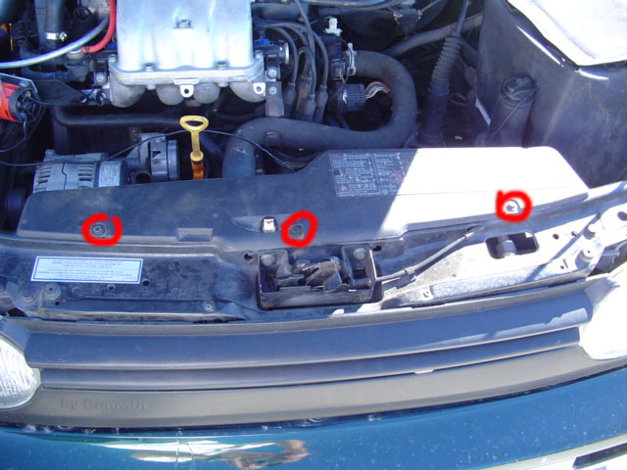
Under it, you'll see a big connector
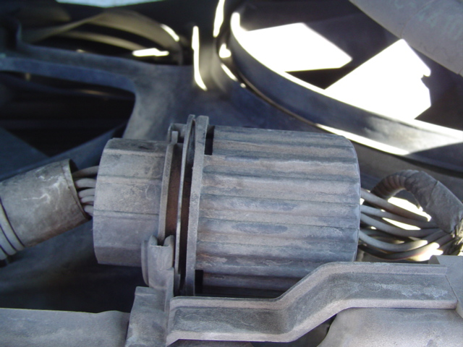
Twist and pull this sucker apart, then read more instructions on the wiring harness.. Says to locate the female side (receiving end of wires) and locate a GRAY with a YELLOW pinstripe.
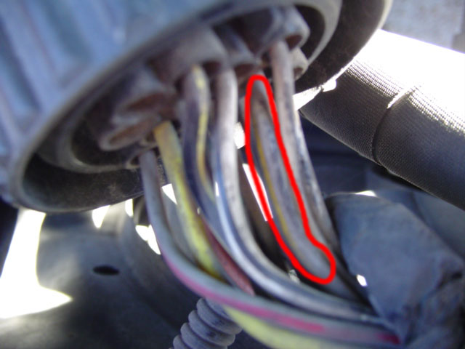
Now on the male side, locate it and take a strong WD40 straw and start pushing it through from the pin's side.
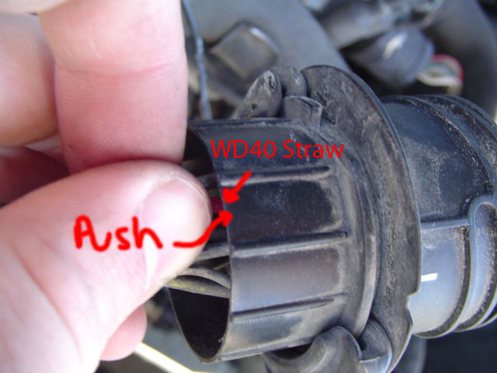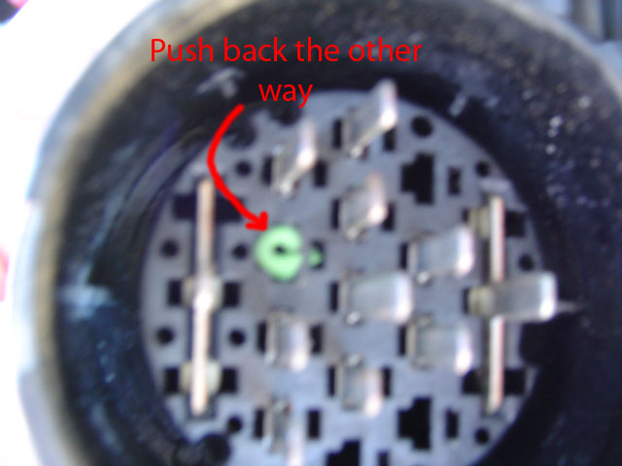
After that damn green thing is out.. Feed the gray wire on the wiring harness through the hold to fit in with the other pins there.
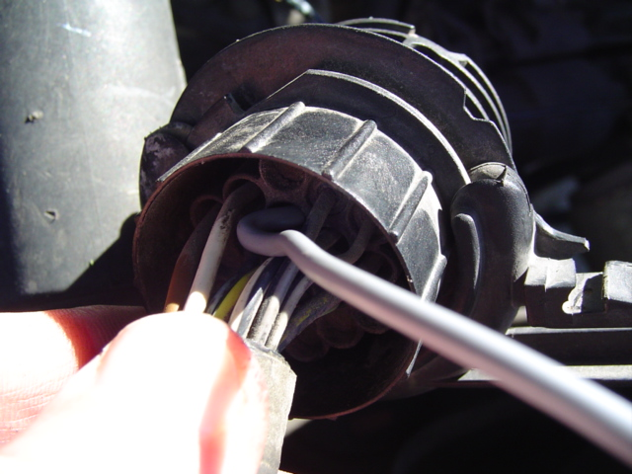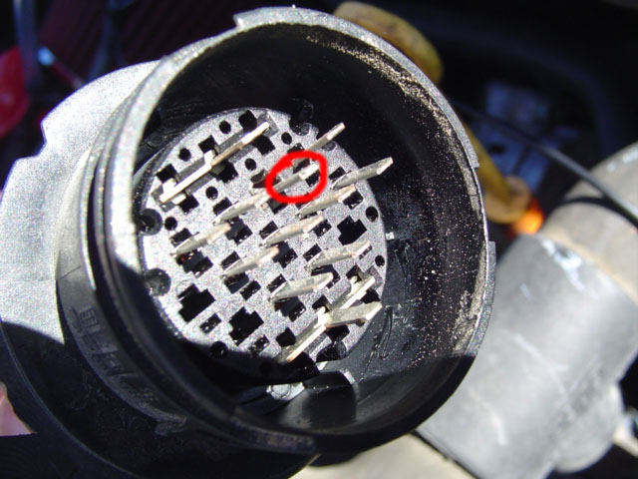
After that is done, line all the pins back together and connect and push together while twising. It should close back all the way (this took many trial and error runs before I got it)
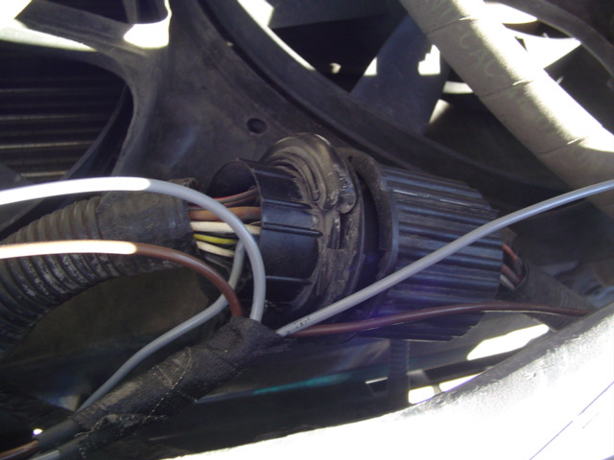
Safely run the wires down the wires where the big connector sat, there should be wire clips where you can interlace these new wires to keep them safe from the belts and coolant lines.
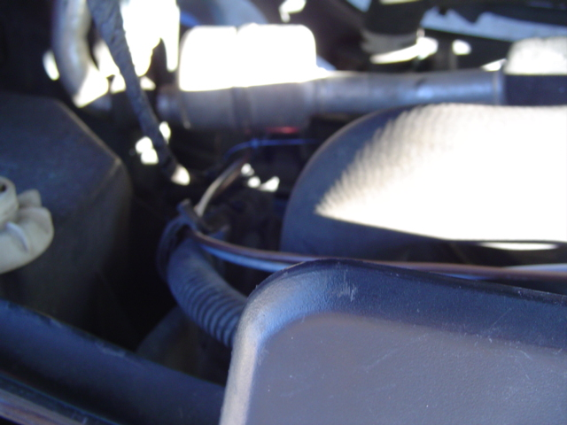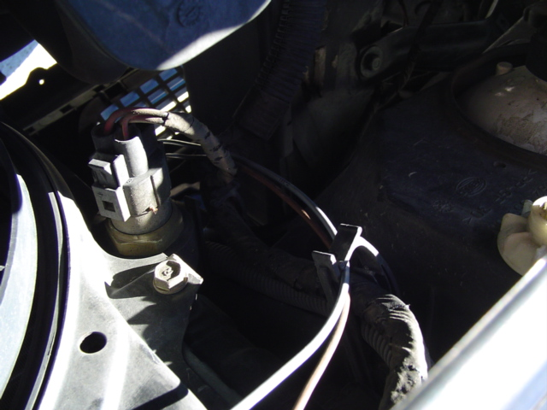
I put the fogs in without the lenses as a test run to make sure they worked (always a good idea in case they dont)
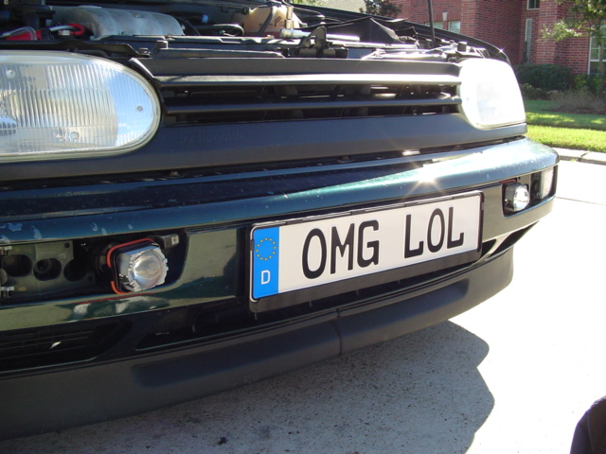
Keep in mind, if the fogs are switched places, they will not turn on! That already happened to me and I'm glad I figured it out.
Now turn on the foglights via Turn & Pull out and you should get the little green light
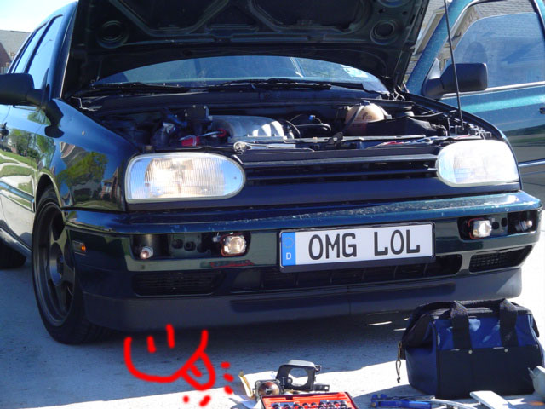
Now piece everything back together. Clamp the fog lenses on the fog lights with the torx screwdriver and secure it to the frame with the holes provided.
Finished:
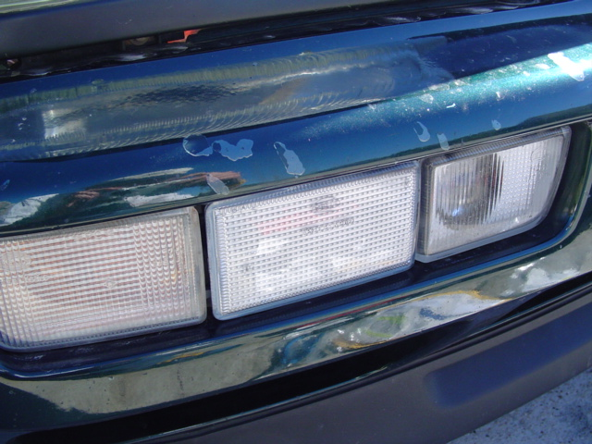
MMmm
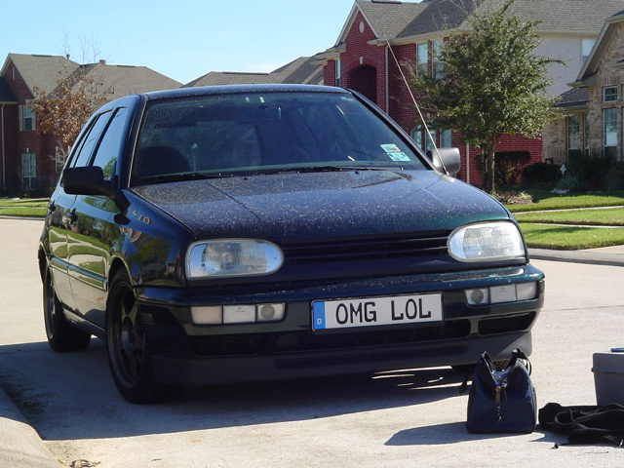
Some vanity shots (Car is dirty.. damn that pollen!!)
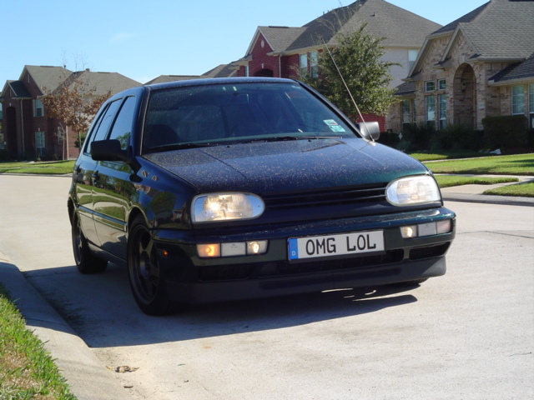
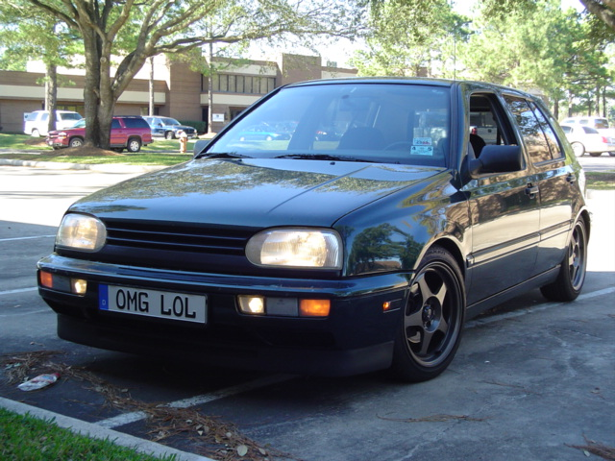
Enjoy!

