Making your side markers blink
http://www.kersur.net/~btillma....html
Wires Before(Drivers side).....
[img]http://www.icbm.org/erkson/personal/mycars/side_marker_1.jpg[/img]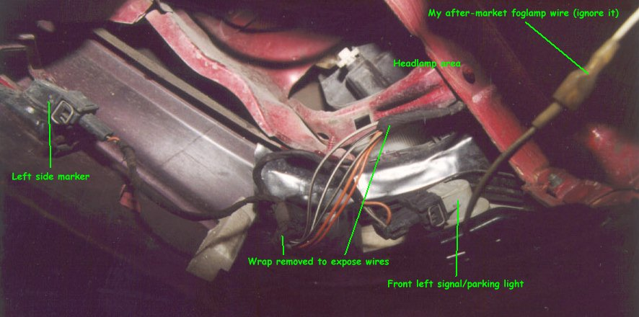
Wires after.....

[img]http://www.icbm.org/erkson/personal/mycars/side_marker_2.jpg[/img]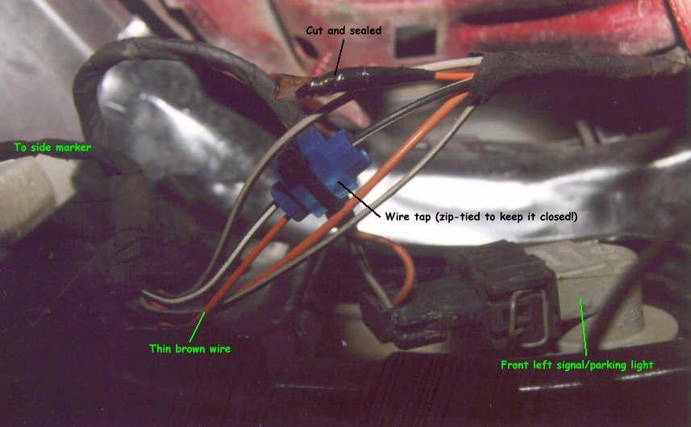
Passenger side.....
[img]http://www.icbm.org/erkson/personal/mycars/side_marker_3.jpg[/img]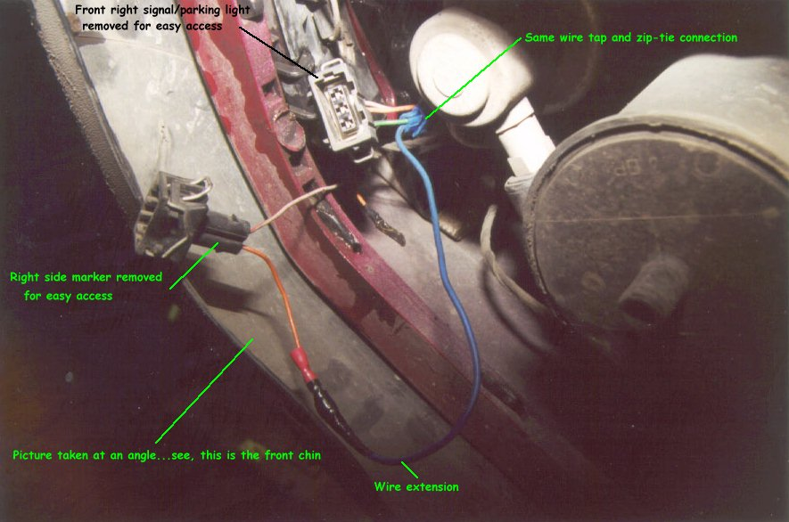
Very easy mod....took me like 15 min. Like the above post...its good to do it from underneath.....but I ended up going through the top...the wires are held with plastic holders.....I just moved them out of the holders and it gave me more than enough slack to get in there. It looks great. Get plenty of looks from other VW's...cause they know it's not supposed to do that. The best look is from the MKIV owners.....lol.

