ever have engine oil on u'r air filter? when the car is driven hard, oil from the pcv feeds back to the intake and then flows back down to the air filter.
i got this idea from the 12v vr forum (http://forums.vwvortex.com/zerothread?id=772790&page=4), but haven't seen any 2.0 ppl do this.
Before:
[img]http://www.geocities.com/mk3dude/dscf3730.txt[/img]
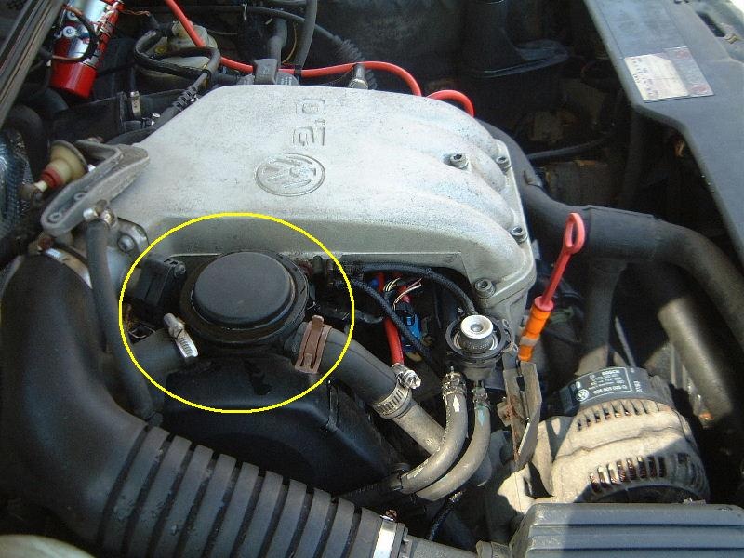
Parts:
[img] http://www.geocities.com/mk3dude/dscf4412.txt[/img]
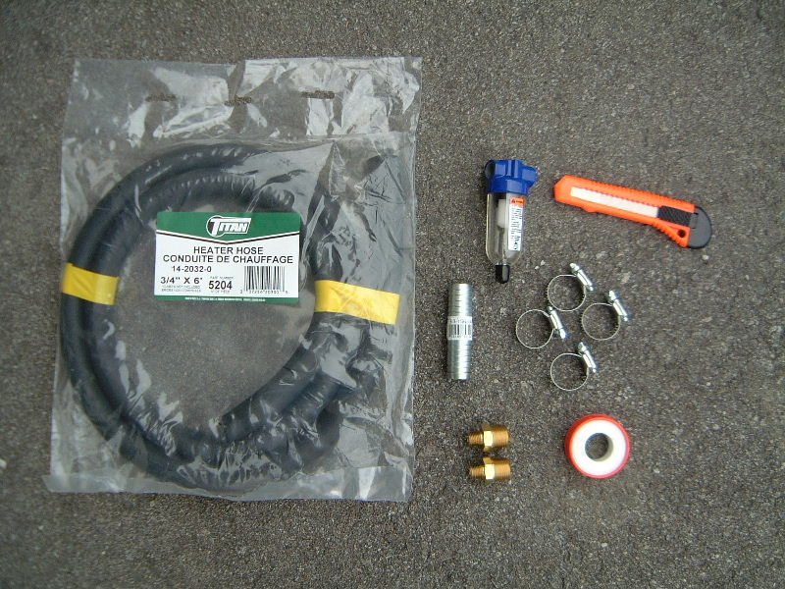
After:
[img] http://www.geocities.com/mk3dude/dscf4413.txt[/img]
