MKIV AEG Intake Manifold install
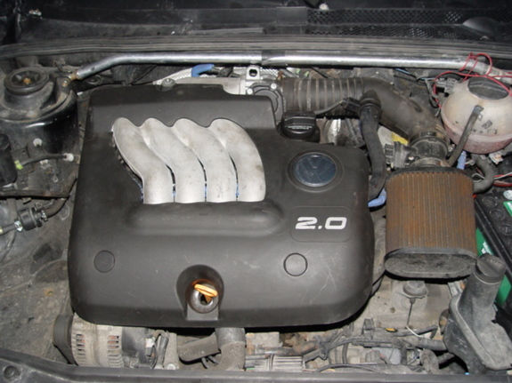
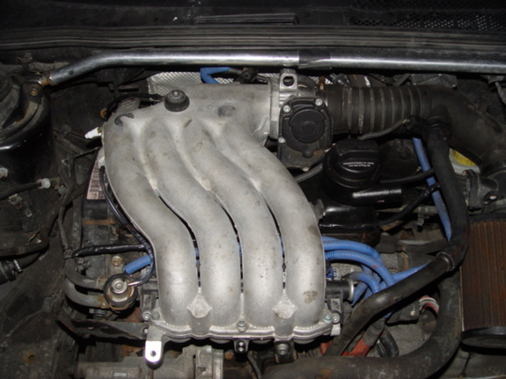
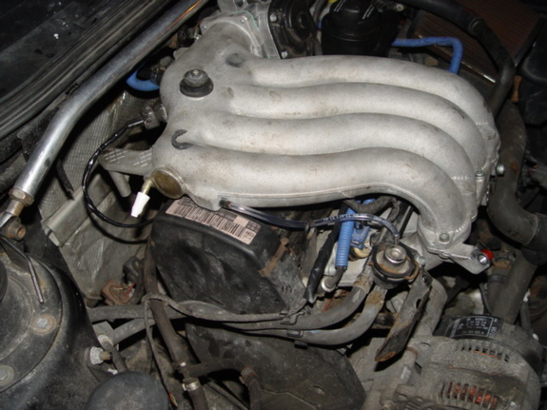
Parts Needed for swap
1 MKIV AEG Upper and Lower Intake Manifold
1 MKIV AEG Valve Cover (MKIII one is too tall)
1 Head to Plenum Gasket
1 Middle Plenum Gasket
1 Throttle Body Gasket
1 Valve Cover Gasket
-10 feet of wire (not sure the gauge but you need it for the IAT and the MAF so whatever that is I just used what i could find that look the same)
-4 Injector Replacement Kits (Comes with 3 O-Rings, 1 Injector Cap per kit)
-1 Foot of 1/8" Vacuum Hose (Autozone or Canadian Tire)
-5 Bolts for connecting the 2 pieces of the intake together (you may find most or all being used for odd things on the MKIII or MKIV manifold make sure you have them.....
-Plug (I used a cap from a Caulking tube .....temp until i find something better)
-051 103 211A - Part Number for Hose that connect the Crankcase to the valve cover to the intake pipe (about 20 bucks at the dealer)
or
-1 Universal Breather Filter, 1 Foot of 3/4" Heater Hose (Canadian Tire or Autozone)
Tools Needed for Job
-Rachet Set
-19mm wrench or 19mm deep socket to take off the IAT from the old manifold
-Drill and bits
-Metric Tap and Die set or JB WELD (i used this....couldnt find a tap set)
-Allen Keys
-Hex Keys (May not need I needed one to get the last bolt out of the Throttle Body)
-Xacto Knife
-Needle Nose Pliers
-Robertson (Black), Phillips (small star), Flat Head
-Clamping Pliers
-couple of goodsize books (or something that will hold up the gas pedal)
OK....Now the Install
-Disconnect the Battery
-put books under the gas pedal
-Take the Intake Piping out (Unplug all wiring MAF..etc.)
-Take out upper intake plenum
-Disconnect the plugs from the Injectors
-Take off the Metal Clips that hold the Injectors to the Fuel Rail (Save youll Need these)
-Remove Fuel Rail (WARNING! You will spill gas!)
-Pull all the injectors out of the Head (I waited until after i took the lower piece off and i found it to be a pain prolly easier if its still on there)
-Take off the Lower part of the Manifold and put on a new gasket and put the new lower manifold on
-Take the Injectors and put the caps off (may be difficult - I used Needle Nose to pull then off)
- Replace the Injector 2 Rubber O-Rings and the 1 Plastic O-Ring with 3 Rubber O-Rings
- Replace the Caps with new ones in the kit (after putting on make sure you hear the click)
- Push Injectors back into the Lower Manifold Piece
- Put Fuel Rail back on
- Put Clips back on
- Take Throttle Body off old Intake get some Paper towel and clean out the inside of it
- Turn TB upsidedown and put it on the MKIV Manifold
- Now take the IAT out of the side of the Old Mani and find the right size bit and drill into the back of the manifold then tap the hole out ( I used an oversized bit and then JB Welded the IAT in place because i couldnt find a kit and i wasnt spending 40 bucks on one.....)
- Take off the MKIII Valve Cover and PCV and replace the Valve Cover Gasket
- Put in the MKIV AEG Valve Cover
- Install MKIV PCV Assembly
- Put Gasket and Upper Manifold on
- Extend IAT is on the same line as the plugs for the injectors (cut 2 - 1 foot pieces of wire)
- Plug injectors back in
- If using JB Weld for the IAT do not plug back in until a little later to let it dry a little first
- Extend MAF Wiring (Cut 4 - 2 foot Pieces) route inbetween the manifolds
- Connect the FPR to the intake manifold with the foot long piece of 1/8" vacuum tube
- Connect the Vacuum Line Coming from the EVAP Purge Regulator to its spot that you took it out of on the Throttle Body
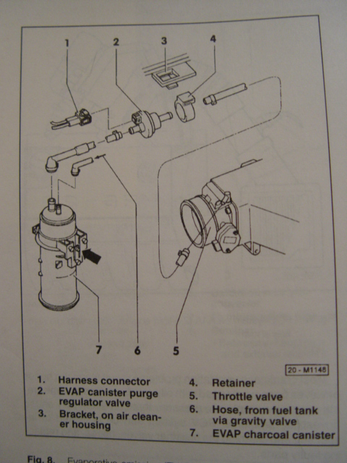
- Connect the Vacuum line that Comes from the TB and goes to the side of the Intake
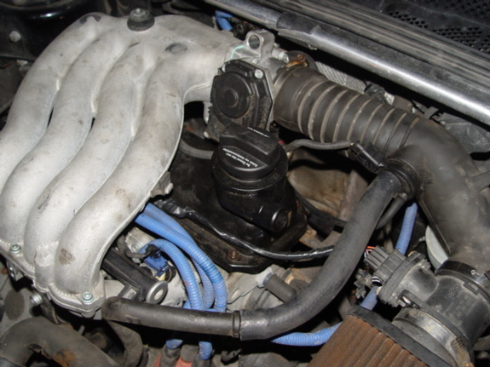
- Twist the Plastic Hose Coming up from the Crankcase and put the 3/4 Piece of Heater Hose and connect it to the intake (or Use the factory piece that i gave a part number for above)
- if you dont use the factory piece then put a breather filter on the PCV (not in picture got it after i took the picture)
-Plug off the Vacuum i used a cap from MONO Caulking (lack of better thing at the time)
-Plug in IAT
-Plug Battery In
- Play around until you get the throttle cable right......then take the books out (I did it with the car running so that I could get the right idle
RE-ADAPT YOUR IDLE - Steps without a VAG-COM
-Disconnect the Battery for 3 minutes
-After the Battery is plugged back in turn your key to the on Position for 3 minutes
-Start Car let Idle for 3 minutes
-Drive out of your spot rev the car over 5000 in second then pull over and turn car off
-Start Car and your all done
- put cover on if you have one.....your done....Drink
Any Questions Feel Free to IM me
If anyone has any pictures of the Secondary Air Pump I would like to see how that would connect with everything ..... a couple shots of the engine bay would be nice
Modified by duke_seb at 6:58 PM 3-28-2006

