The airbox/intake modification:
Best bang for the buck is as follows...
Let me say that you are almost definitely losing power with a cone filter, instead of the airbox in place because you are sucking in hot air from the motor. Cone filters work in either a cold air intake or when being used with a heat shield. To further prove to you the power loss of a cone filter in place of an airbox, here is a dyno test from Techtonics Tuning of an open-element conical filter versus an airbox. There is quite a drastic loss in power with the conical filter. http://www.techtonicstuning.co...7.JPG
First, buy a K&N (or ITG) drop-in panel filter.
What I did, and what many others do, is modify the stock airbox. All you really need is a dremel, or maybe a utility knife, if that may work [I used a dremel].
Next, is cutting out part of the front/fender side of the airbox. I used a ruler and straight blade to slightly draw out where I wanted to cut exactly. I used many of the airbox’s lines to cut the cleanest looking cut. Those who say to swiss cheese doesn't make sense when you can just cut a whole clean piece from the airbox. It will flow better air and look much more professional/clean. You honestly can't tell the airbox is modified if you do it in this manner.
Here is my setup.
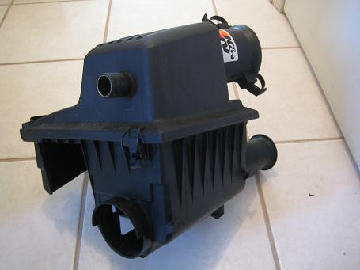
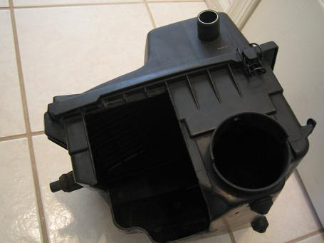
Here with K&N panel filter inside...
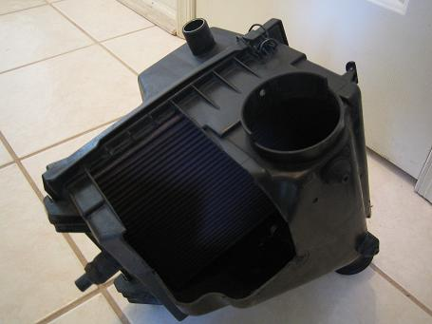
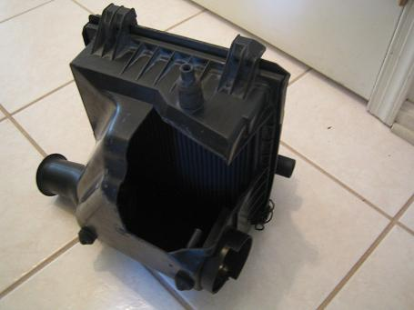
In the upper airbox, there is a duct in the upper section of the airbox that I removed. Notice the difference in diameter after removing the duct. Quite bigger and it also sucks more air in from the whole panel, rather than a portion before.
To remove air duct, take two flatheads and stick in between the duct and upper airbox, unplugging the tabs. Leave the flatheads in there after unplugging the tabs. Then, take small pliers and grab a nice hold of the duct and pull out with some force.
NOTICE: Some people say this duct basically acts like a velocity stack and that it helps directs air to the MAF. Not sure how much it helps or doesn't, however, I still opted to take it out. I'm willing to sacrifice this piece by looking at the bore of the intake afterwards.
With the duct in the upper airbox...
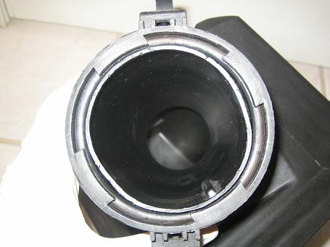
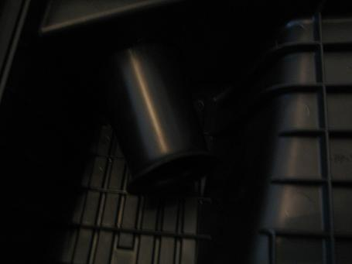
Without the air duct...Notice the difference?
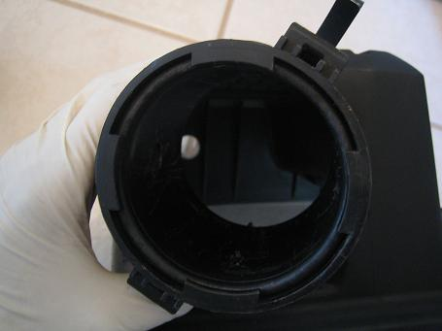
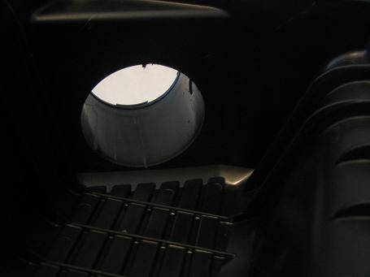
And the velocity stack removed from the airbox.
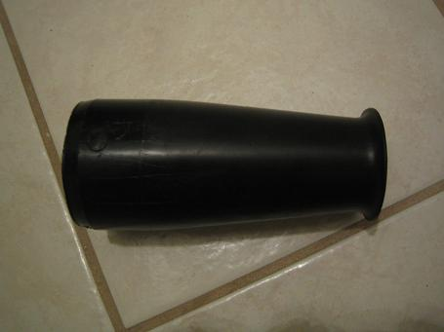
Remove this plastic honeycomb piece from the MAF. There is no point in this piece since there is an air filter. I’ve been running without this piece for a long time without any problems.
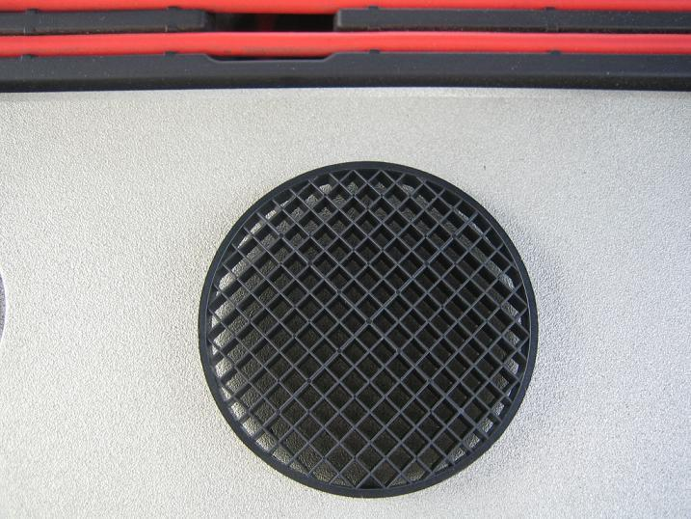
That plastic piece removed gives you a straight through MAF…
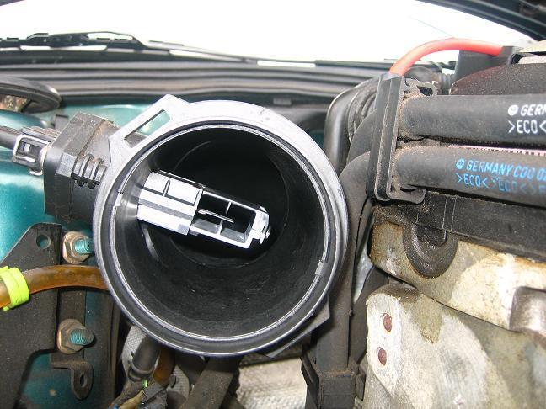
Remove this piece from the fender area. It is for the bent duct (can get a picture if needed) that is used to route into the fender. This piece is pointless now that the airbox is opened up and there is no velocity sucking air from it anymore. It just blocks air from the front of the airbox now. If it wasn’t cut open, then this duct would makes sense. I removed it completely.
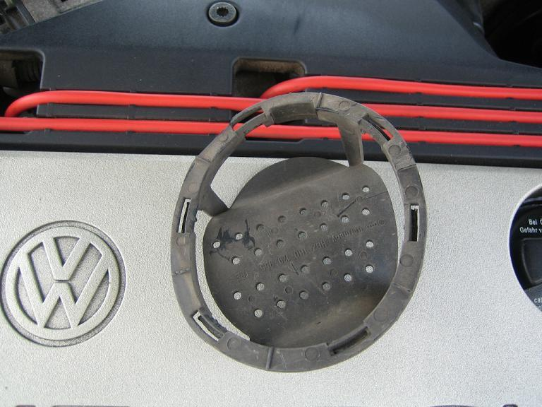
And the result of that being removed is more air from the fender area…
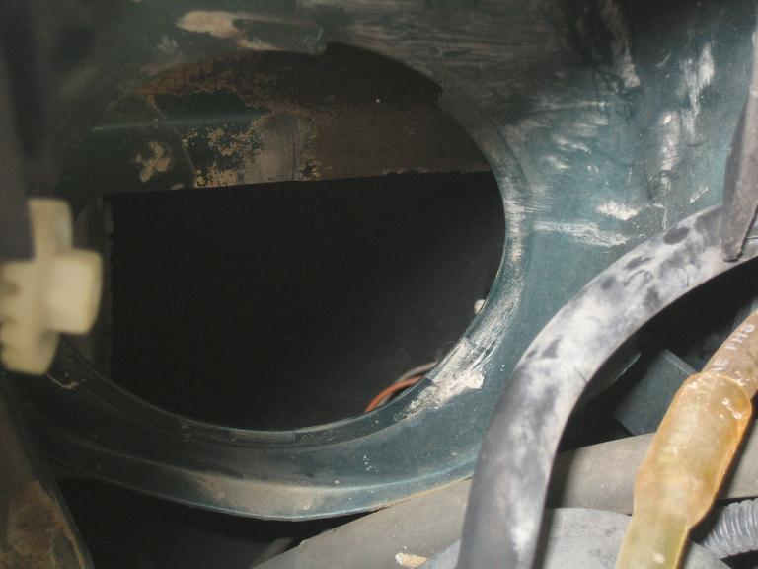
And some shots of how the airbox sits…
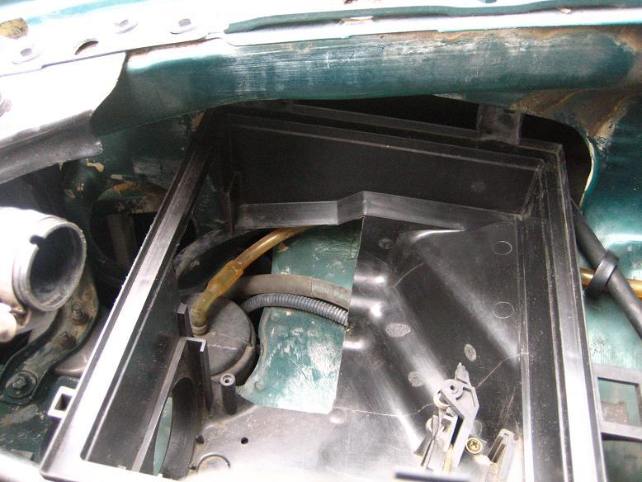
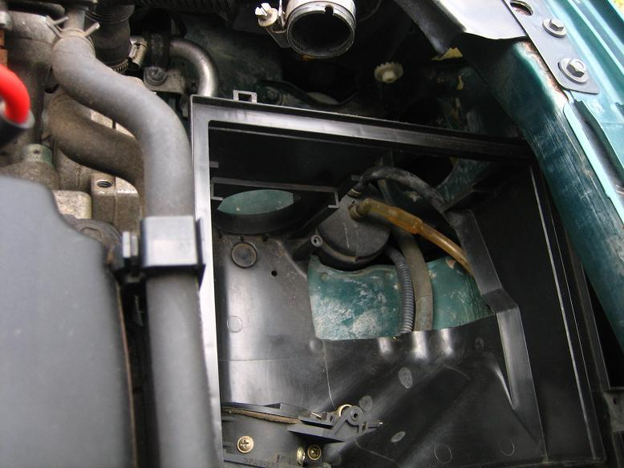
Enjoy the noticeable performance from these modifications. My track times prove it. I did this for the performance of course, but the sound that comes with it is unbelievable. You will have heads turning left and right when they hear it. Good luck.
Modified by Breezy. at 3:01 PM 9-22-2006

